

Navigating the Pharmaceutical Landscape: An Exploration of Emotional Intelligence, Job Satisfaction, and Organizational Dynamics

**Manmohan Singh Raghuwanshi**

Final Thesis Report

**June 2022**

## Dedications

I dedicate this work to my family **Mr. Amrish Thakur and Mrs. Savitri Thakur**, who watched so much and sacrificed to see me educated, and succeed in my studies, and My sisters **Kalpana Raghuwanshi** have never left my side and are very special.

To my dear mother, whom I hold dear in this world, my model of sacrifice, of generosity, the star of my life, which has always sacrificed, helped, prayed for me to get there at this point today, to whom I wish a very long life full of health and of joy.

To my dear brothers and sisters whom I carry a great deal in my heart, my daily strength, who taught me a lot of things in life.

To my friends **Narendra Jetley and Jigyasa Singh**

## Acknowledgement

I would like to express my thanks and deep gratitude to my supervisor, **Dr. Rekha Thakran** for his valuable advice, his patience, and his availability. I also thank for his experienced advice, which was very beneficial and helped me to accomplish this study. I would also like to thank all those who have supported me in my work,

On a more personal note, I would like to thank all my family, especially my mother. Finally, I thank my friends and my colleagues from the **Liverpool John Moores University**.

**Table of Content**

Dedications 2

Acknowledgement 3

**Table of Content** 4

Abstract 6

List of Table 7

List of Figure 8

LIST OF ABBREVIATIONS 9

CHAPTER 1 10

INTRODUCTION 10

**1.1.** **User Satisfaction Assessment in AI-integrated CRM Solutions** 10

**1.2.** **The Ripple Effect of AI-Enabled Personalization in CRM Dynamics** 11

**1.3.** **Navigating the Challenges: AI Components in Salesforce CRM** 11

**1.4.** **Background of Study** 12

**1.4.1.** **The Evolution of CRM Systems** 12

**1.4.2.** **The Rise and Implications of AI Integration in CRM** 13

**1.4.3.** **Navigating the Implications of AI-Driven CRM** 13

**1.5.** **Research Questions** 15

**1.6.** **Aim & Objective** 15

CHAPTER 2 17

LITERATURE REVIEW 17

2.1. AI use in Salesforce CRM 17

**2.2.** **AI-enhanced CRM** 18

CHAPTER 3 20

METHODOLOGY 20

**3.1.** **Rationale** 20

**3.2.** **Hypothesis** 20

**3.3.** **Type of Study** 20

**3.4.** **Research Philosophy** 21

**3.5.** **Research Approach** 21

**3.6.** **Type of study** 21

**3.7.** **Sample Size** 21

**3.8.** **Statistical Analyses** 21

**3.9.** **Research Strategy** 22

**3.10.** **Data Collection** 22

**3.11.** **Designing the Questionnaire** 22

**3.12.** **Ethical Considerations** 22

**3.13.** **Reliability** 22

CHAPTER 4 23

DATA INTERPRETATION 23

**4.1.** **Frequency Table** 23

**4.2.** **Crosstabulation** 28

CHAPTER 5 66

RESULTS 66

**5.1.** **Bivariate correlation** 71

**5.2.** **ANOVA** 72

**5.3.** **Reliability** 73

## Abstract

The integration of artificial intelligence (AI) into Salesforce CRM has transformed user experiences in the business world. This research aimed to meticulously assess user satisfaction concerning these AI-integrated features, focusing on interface design, system responsiveness, and overall user engagement. We also delved into understanding the perceived impact of AI-driven personalization on user engagement and its outcomes during customer interactions. This deep dive highlighted that while AI provides immense advantages, there are challenges users encounter. The objective was to bring these challenges to the forefront to suggest potential areas for improvement. Through structured methodologies, empirical research, and extensive data collection via tools Google Forms, the study aimed to derive concrete findings. The data was critically analyzed, ensuring the application of ethical practices throughout the research process. The study used both qualitative and quantitative approaches, emphasizing primary data to capture current industry trends. Analytical tools, including SPSS, were employed to ensure accuracy. The outcomes are expected to reflect enhanced user satisfaction due to intuitive AI features, a boost in user engagement, insights into challenges faced, and potential areas for CRM system refinements. This research is poised to offer valuable insights to businesses relying on Salesforce CRM, helping them leverage AI benefits while being aware of its challenges.

**Keyword:** artificial intelligence, Salesforce, CRM, multiple dimensions, Salesforce and customer interactions.

## List of Table

Table 4.1: Gender 14

Table 4.2: Age 15

Table 4.3: Qualification 16

Table 4.4: Experience 17

Table 4.5: Income Tax Slab? (Rupees) 18

Table 4.7: Gender * Which AI feature in Salesforce CRM do you think requires the most immediate refinement, in terms of your satisfaction? Crosstabulation 20

Table 4.8 Gender * Which aspect of AI features would you prioritize for improvement, in terms of your satisfaction? Crosstabulation 21

Table 4.9: Gender * How satisfied are you with the responsiveness of the AI components within Salesforce CRM? Crosstabulation 22

Table 4.10: Gender * How satisfied are you with the frequency of encountering issues or errors when using AI features in Salesforce CRM? Crosstabulation 23

Table 4.11: Gender * How satisfied are you with the relevance of the recommendations or insights provided by AI-driven personalization in Salesforce CRM? Crosstabulation 25

Table 4.12: Gender * How satisfied are you that AI-driven personalization enhances your engagement with the CRM system? Crosstabulation 26

Table 4.13: Age * Which AI feature in Salesforce CRM do you think requires the most immediate refinement, in terms of your satisfaction? Crosstabulation 27

Table 4.14: Age * Which aspect of AI features would you prioritize for improvement, in terms of your satisfaction? Crosstabulation 28

Table 4.15: Age * If Salesforce CRM were to focus on one area for improvement in its AI integration, which area would you prefer? Crosstabulation 30

Table 4.16: Age * How would you rate the intuitiveness of the user interface of AI-integrated features in Salesforce CRM? Crosstabulation 31

Table 4.17: Age * How satisfied are you with the responsiveness of the AI components within Salesforce CRM? Crosstabulation 33

Table 4.18: Age * How satisfied are you with the way AI features in Salesforce CRM understand and cater to your requests or queries? Crosstabulation 34

Table 4.19: Qualification * Which AI feature in Salesforce CRM do you think requires the most immediate refinement, in terms of your satisfaction? Crosstabulation 35

Table 4.20: Qualification * Which aspect of AI features would you prioritize for improvement, in terms of your satisfaction? Crosstabulation 37

Table 4.21: Qualification * If Salesforce CRM were to focus on one area for improvement in its AI integration, which area would you prefer? Crosstabulation 38

Table 4.21: Qualification * How would you rate the intuitiveness of the user interface of AI-integrated features in Salesforce CRM? Crosstabulation 40

Table 4.22: Qualification * How satisfied are you with the responsiveness of the AI components within Salesforce CRM? Crosstabulation 41

Table 4.23: Experience * How satisfied are you with the way AI features in Salesforce CRM understand and cater to your requests or queries? Crosstabulation 43

Figure 4.24: Experience * How satisfied are you with the frequency of encountering issues or errors when using AI features in Salesforce CRM? Crosstabulation 44

Table 4.25: Experience * How satisfied are you with the relevance of the recommendations or insights provided by AI-driven personalization in Salesforce CRM? Crosstabulation 45

Table 4.27: Income Tax Slab? (Rupees) * How would you rate the intuitiveness of the user interface of AI-integrated features in Salesforce CRM? Crosstabulation 48

Table 4.28: Income Tax Slab? (Rupees) * How satisfied are you with the responsiveness of the AI components within Salesforce CRM? Crosstabulation 50

Table 4.29: Income Tax Slab? (Rupees) * Regarding the main challenges with AI components in Salesforce CRM, how satisfied are you with the resolution or management of these challenges? Crosstabulation 51

Table 4.30: Job Role * How satisfied are you with the frequency of encountering issues or errors when using AI features in Salesforce CRM? Crosstabulation 52

Table 4.31: Job Role * How satisfied are you with the relevance of the recommendations or insights provided by AI-driven personalization in Salesforce CRM? Crosstabulation 54

Table 4.32: Job Role * How satisfied are you that AI-driven personalization enhances your engagement with the CRM system? Crosstabulation 55

Table 5.1: Bivariate correlation 62

Table 5.2: Variables Entered/Removed 63

Table 5.3: Model Summary 63

Table 5.4: ANOVA 64

Table 5.5: Reliability 64

## List of Figure

Figure 4.1: Gender 14

Figure 4.2: Age 15

Figure 4.3: Qualification 16

Figure 4.4: Experience 17

Figure 4.5: Income Tax Slab? (Rupees) 18

Figure 4.6: Job Role 19

Figure 4.7: Gender * Which AI feature in Salesforce CRM do you think requires the most immediate refinement, in terms of your satisfaction? Crosstabulation 21

Figure 4.8 Gender * Which aspect of AI features would you prioritize for improvement, in terms of your satisfaction? Crosstabulation 22

Figure 4.9: Gender * How satisfied are you with the responsiveness of the AI components within Salesforce CRM? Crosstabulation 23

Figure 4.10: Gender * How satisfied are you with the frequency of encountering issues or errors when using AI features in Salesforce CRM? Crosstabulation 24

Figure 4.11: Gender * How satisfied are you with the relevance of the recommendations or insights provided by AI-driven personalization in Salesforce CRM? Crosstabulation 25

Figure 4.12: Gender * How satisfied are you that AI-driven personalization enhances your engagement with the CRM system? Crosstabulation 26

Figure 4.13: Age * Which AI feature in Salesforce CRM do you think requires the most immediate refinement, in terms of your satisfaction? Crosstabulation 28

Figure 4.14: Age * Which aspect of AI features would you prioritize for improvement, in terms of your satisfaction? Crosstabulation 29

Figure 4.15: Age * If Salesforce CRM were to focus on one area for improvement in its AI integration, which area would you prefer? Crosstabulation 31

Figure 4.16: Age * How would you rate the intuitiveness of the user interface of AI-integrated features in Salesforce CRM? Crosstabulation 32

Figure 4.17: Age * How satisfied are you with the responsiveness of the AI components within Salesforce CRM? Crosstabulation 33

Figure 4.18: Age * How satisfied are you with the way AI features in Salesforce CRM understand and cater to your requests or queries? Crosstabulation 35

Figure 4.19: Qualification * Which AI feature in Salesforce CRM do you think requires the most immediate refinement, in terms of your satisfaction? Crosstabulation 36

Figure 4.20: Qualification * Which aspect of AI features would you prioritize for improvement, in terms of your satisfaction? Crosstabulation 38

Figure 4.21: Qualification * If Salesforce CRM were to focus on one area for improvement in its AI integration, which area would you prefer? Crosstabulation 39

Figure 4.21: Qualification * How would you rate the intuitiveness of the user interface of AI-integrated features in Salesforce CRM? Crosstabulation 40

Figure 4.22: Qualification * How satisfied are you with the responsiveness of the AI components within Salesforce CRM? Crosstabulation 42

Figure 4.23: Experience * How satisfied are you with the way AI features in Salesforce CRM understand and cater to your requests or queries? Crosstabulation 43

Figure 4.24: Experience * How satisfied are you with the frequency of encountering issues or errors when using AI features in Salesforce CRM? Crosstabulation 45

Figure 4.25: Experience * How satisfied are you with the relevance of the recommendations or insights provided by AI-driven personalization in Salesforce CRM? Crosstabulation 46

Figure 4.26: Experience * How satisfied are you that AI-driven personalization enhances your engagement with the CRM system? Crosstabulation 48

Figure 4.27: Income Tax Slab? (Rupees) * How would you rate the intuitiveness of the user interface of AI-integrated features in Salesforce CRM? Crosstabulation 49

Figure 4.28: Income Tax Slab? (Rupees) * How satisfied are you with the responsiveness of the AI components within Salesforce CRM? Crosstabulation 50

Figure 4.29: Income Tax Slab? (Rupees) * Regarding the main challenges with AI components in Salesforce CRM, how satisfied are you with the resolution or management of these challenges? Crosstabulation 52

Figure 4.30: Job Role * How satisfied are you with the frequency of encountering issues or errors when using AI features in Salesforce CRM? Crosstabulation 53

Figure 4.31: Job Role * How satisfied are you with the relevance of the recommendations or insights provided by AI-driven personalization in Salesforce CRM? Crosstabulation 54

Figure 4.32: Job Role * How satisfied are you that AI-driven personalization enhances your engagement with the CRM system? Crosstabulation 56

## LIST OF ABBREVIATIONS

CRM……..Customer Relationship Management

AI………...Artificial intelligence

UI…………User Interface

## CHAPTER 1

## INTRODUCTION

* 1. **User Satisfaction Assessment in AI-integrated CRM Solutions**

The landscape of Customer Relationship Management (CRM) software has witnessed a transformative shift over the past decade, evolving from simple contact management systems to complex tools embedded with artificial intelligence (AI) capabilities. At the heart of this revolution lies a critical emphasis on understanding and enhancing the end-user experience. With global businesses vying for a competitive edge, the effectiveness of a CRM platform is often determined not just by its features but by how users perceive and interact with those features (Singh & Kumar, 2018).

Salesforce, a global leader in CRM solutions, has been at the forefront of integrating AI components into its platform, aiming to offer a seamless and efficient user experience. However, as with any technological advancement, the introduction of AI brings forth new dimensions to consider, especially in terms of user satisfaction. User Interface (UI) intuitiveness, system responsiveness, and an all-encompassing user experience are pivotal to ensure the platform's success (Johnson, 2019). An intuitive UI can significantly reduce the learning curve, allowing users to harness the power of AI features without feeling overwhelmed (Peters & Thompson, 2020). Meanwhile, system responsiveness is closely linked to user satisfaction; delays in system reactions can deter users, potentially undermining the advantages AI might bring. Lastly, a comprehensive user experience integrates these components, ensuring users not only complete tasks efficiently but also derive satisfaction from the process (Nguyen & Brooks, 2017).

While Salesforce's initiatives in AI integration have garnered attention, there remains a significant need for systematic measurement of end-user satisfaction levels concerning these AI-enhanced features. Only through detailed assessments can businesses truly gauge whether the AI tools are augmenting user experience or becoming unintended obstacles (Davis & Olson, 2019).

* 1. **The Ripple Effect of AI-Enabled Personalization in CRM Dynamics**

In the digital age, one-size-fits-all is rapidly becoming an obsolete concept. Contemporary users, whether they are business professionals or end consumers, expect products and services tailored to their specific needs and preferences (Anderson & Rainie, 2018). This escalating demand for personalization has pushed industries to adapt and innovate, with the CRM domain being no exception. Platforms like Salesforce have started leveraging the predictive prowess of artificial intelligence to drive personalization, ensuring every user touchpoint is relevant, timely, and contextually appropriate (Kapoor & Jones, 2019).

Personalization, bolstered by AI, stands as a double-edged sword. On one hand, it holds the potential to drastically improve user engagement, turning mundane interactions into delightful experiences. Studies indicate that personalized user interfaces and experiences can lead to heightened engagement rates, reduced churn, and amplified loyalty (Roberts & Kray, 2020). Moreover, from the perspective of customer interaction outcomes, AI-driven personalization can provide businesses with nuanced insights about their clientele, facilitating better targeting, more successful campaigns, and enhanced customer relationships (Greenwood & Smith, 2018).

It's essential to approach this promising horizon with a discerning eye. How do users truly perceive these AI-enabled personalizations? Are they embraced as enhancements or dismissed as mere distractions? While Salesforce CRM's endeavors in personalization are commendable, a comprehensive inquiry into the perceived value and actual impact of these features remains crucial. Only with rigorous research can businesses separate the genuine game-changers from the fleeting gimmicks (Lee & Murphy, 2019).

* 1. **Navigating the Challenges: AI Components in Salesforce CRM**

Amid the glowing promise of AI's potential, it's crucial not to lose sight of the challenges and barriers that arise when new technologies intersect with human users. The fusion of AI components within Salesforce CRM, while revolutionary, is not without its hurdles (Watson & Fernandez, 2018). As businesses rush to integrate AI into their CRM processes, the user's journey—filled with triumphs but also occasional stumbles—becomes an essential narrative to uncover.

The introduction of new technology in established processes has often been met with resistance, not necessarily due to the technology's inefficiency but because of the barriers users face in terms of adaptability, understanding, and acceptance (Martin & Turner, 2019). The dynamics of Salesforce's AI components present similar challenges. Some of these barriers are system-related, stemming from limitations or inefficiencies within the AI system itself. These can manifest as bugs, counter-intuitive designs, or simply an AI response that misaligns with the user's expectations (Garcia & Lewis, 2020). However, an equally pressing concern arises from user-related challenges. These encompass issues like reluctance to adapt, lack of sufficient training or understanding, and inherent biases against AI-assisted decision-making (Patel & Roberts, 2020).

Recognizing and addressing these challenges isn't merely a technical endeavor but a holistic one, ensuring that the platform serves its users, rather than the other way around. For Salesforce CRM's AI capabilities to truly shine, an in-depth understanding of these barriers and challenges becomes imperative. By mapping out these pain points, businesses can aspire to refine and enhance their systems, making them not just technologically advanced but also user-centric (Kim & Johnson, 2019).

* 1. **Background of Study** 
     1. **The Evolution of CRM Systems**

Customer Relationship Management (CRM) has firmly established itself as an indispensable tool for businesses across the globe. Originating from simple contact management systems in the late 20th century, CRM platforms have burgeoned into multifaceted software, designed to streamline customer interactions, boost sales, and enhance marketing endeavors (Brown & Green, 2015).

The transition from traditional paper-based methods to digitized databases during the late 1990s and early 2000s marked a significant shift in the CRM landscape. These digital platforms provided organizations with a unified space to store, manage, and analyze customer data, paving the way for more targeted and efficient customer interactions (Roberts & Jackson, 2017).

As global markets expanded and customer bases diversified, businesses sought advanced tools to understand and cater to their clientele's evolving demands. This demand coincided with the technological boom of the 21st century, resulting in the integration of analytics, cloud computing, and, more recently, artificial intelligence into CRM platforms, each addition aiming to enrich the user experience and provide deeper customer insights (Turner & Smith, 2018).

* + 1. **The Rise and Implications of AI Integration in CRM**

As the technological horizon expanded, Artificial Intelligence (AI) emerged as a transformative force, challenging and redefining traditional paradigms across various sectors, including the CRM domain. By the mid-2010s, AI had started to make its presence felt in CRM systems, promising a blend of automation, predictive analytics, and enhanced customer understanding (Mitchell & Daniels, 2016).

The application of AI in CRM can be traced back to the integration of chatbots and automated customer service tools. These initial integrations were rudimentary, focused primarily on handling frequently asked questions or directing users to relevant resources. However, as AI algorithms became more sophisticated, so did their capabilities within CRM platforms. Features such as predictive sales analytics, customer sentiment analysis, and personalized marketing strategies began to emerge, powered by AI's ability to process vast amounts of data and derive meaningful insights (Hamilton & Lee, 2019).

Salesforce, a leader in the CRM landscape, was among the pioneers to recognize and harness AI's potential. Their AI-powered assistant, Einstein, introduced capabilities like predictive lead scoring, automated data entry, and tailored product recommendations, marking a significant shift in how businesses perceived and interacted with their customer data (Baxter & Thompson, 2020).

These advancements came a new set of challenges. As CRM platforms became more complex and feature-rich, businesses faced the daunting task of ensuring these tools remained user-friendly and did not overwhelm or alienate their user base. The balance between sophistication and simplicity became a focal point of CRM design and development, with user satisfaction playing a central role in shaping the trajectory of AI-integrated CRM systems (Gomez & Patel, 2021).

* + 1. **Navigating the Implications of AI-Driven CRM**

The marriage of AI and CRM, while heralding unparalleled advancements, also brought to light an intricate web of implications for businesses and end-users. At the core of these implications lay three intertwined dimensions: user satisfaction, personalization, and the barriers challenging seamless AI-CRM interactions.

User Satisfaction: The very essence of integrating AI into CRM revolved around enhancing user experience, be it through automating mundane tasks, providing predictive insights, or optimizing sales processes. A study by Williams & Turner (2019) revealed a direct correlation between AI-driven features and enhanced user productivity. However, this increase in productivity often walked a tightrope with user satisfaction. The introduction of new features, while powerful, risked overwhelming users, necessitating robust training and intuitive UI/UX design. An analysis by O'Connor & Li (2020) argued that satisfaction didn't just stem from a feature's capability but also its ease of use and integration into daily workflows.

Personalization Impact: AI's promise of personalization in CRM emerged as a game-changer. By tailoring interactions based on historical data and predictive analytics, businesses could foster deeper customer connections and drive engagement. Martin & Singh (2021) highlighted the role of AI-driven personalization in reducing churn rates and increasing customer lifetime value. Yet, striking the right balance between helpful personalization and perceived intrusiveness remained a delicate art. Users demanded relevance without feeling their privacy was compromised, underlining the need for ethical and transparent AI practices.

Barriers & Challenges: The journey of AI-integration in CRM wasn't devoid of roadblocks. Technical glitches, mistrust towards automated decision-making, and the steep learning curve associated with AI features presented significant barriers (Parker & James, 2018). These challenges were not merely technological but also psychological. Addressing them demanded a holistic approach, encompassing robust system design, comprehensive training, and continuous feedback mechanisms.

As businesses and users tread this evolving landscape, the CRM platforms of tomorrow will undoubtedly be shaped by the experiences, feedback, and demands of today. AI's role in this journey, while central, must be navigated with awareness, empathy, and a commitment to user-centric growth.

* 1. **Research Questions**

The following are the research questions outlined based on the Aims and Objectives of the research:

1. How do AI-integrated features in Salesforce CRM influence end-user satisfaction levels, particularly concerning aspects such as user interface intuitiveness, system responsiveness, and overall user experience?
2. Which AI-enabled personalization features within Salesforce CRM are perceived to offer the most value in terms of enhancing user engagement and improving customer interaction outcomes?
3. What are the primary challenges and barriers faced by users when interacting with AI components within Salesforce CRM, and how do they impact the user's overall experience with the platform?
4. Are there specific facets or features of Salesforce CRM's AI components that are consistently identified as areas in need of refinement or improvement?
5. How does the integration of AI in Salesforce CRM affect the balance between advanced functionalities and user-friendliness, and how can this balance be optimized for the benefit of end-users?
6. These research questions are tailored to explore each facet of your objectives in depth, guiding your study towards comprehensive insights. Do you need further modifications or additions?
   1. **Aim & Objective**

To comprehensively evaluate the Effects and Barriers of AI Integration within Salesforce CRM through a User-Centric Study.

Objectives of this research are listed below:

1. Analyzing the degree of end-user satisfaction concerning AI-integrated features within Salesforce CRM, emphasizing user interface intuitiveness, system responsiveness, and the breadth of user experience.
2. Comparing user engagement levels and customer interaction outcomes before and after the implementation of AI-enabled personalization features in Salesforce CRM.
3. Evaluating the potential barriers or challenges users face when interfacing with AI components within Salesforce CRM, with the ultimate goal of improving user experiences.
4. Suggesting areas for system enhancement and refinement.

## CHAPTER 2

## LITERATURE REVIEW

## AI use in Salesforce CRM

Kiryl Kaliuta (2023), this paper provides a conceptual framework for AI deployment in CRM, emphasizing four key sources of value creation in the context of Salesforce CRM. The framework is instrumental in assessing both the impacts and potential impediments of AI integration in such system.

Ankush Milan, Rakesh Sahu, Jasminder Kaur Sandhu (2023), although focusing on social media, this study highlights the broader applications of AI in marketing. It underscores the effectiveness of AI in targeting advertising, understanding consumer perspectives, and safeguarding data privacy. These findings have implications for AI use in Salesforce CRM, particularly in social marketing.

Sheshadri Chatterjee, Patrick Mikalef, S. Khorana, Hatice Kizgin (2022) - This research examines the success and failure of AI-integrated CRM systems in B2C organizations. It finds that information quality, system fit, and organizational fit positively impact implementation, with technology turbulence moderating AI-CRM capability acceptance and failure, relevant for Salesforce CRM

G. Lampropoulos, K. Siakas, Julio A. N. Viana, Olaf Reinhold (2022) - The study demonstrates how integrating AI, Blockchain, Big Data Analytics, Data Mining, and Machine Learning in CRM can enhance performance. Such integration offers enterprises a competitive edge, better customer understanding, and improved profitability, pertinent to Salesforce CRM

Varis, O. Kravchuk, Sofiia Zavhorodnia (2021) - This article focuses on the advantages and disadvantages of digital transformation in businesses, with a specific emphasis on CRM systems. It offers recommendations for addressing shortcomings in existing CRM systems, which can be applied to Salesforce CRM

Hemalatha (2023) - Although this paper does not provide specific information about the impacts and impediments of AI integration in Salesforce CRM, it contributes to the broader discourse on AI deployment in business environments.

Kanwal, Syeda Khadija Hassan, Iffaf Iqbal (2023) - This research explores the perceptions of university-level teachers on Chat-GPT and its potential to improve student learning. While not directly related to Salesforce CRM, it sheds light on the broader educational applications and ethical considerations of AI, which can be extrapolated to business contexts like Salesforce CRM

* 1. **AI-enhanced CRM**

Yanling Dong, Xiaolan Zhou (2023) - The paper discusses advancements in AI-driven language abilities for social robots, touching upon challenges like linguistic understanding and cultural adaptability. This research is relevant for AI-enhanced CRM technologies, particularly in improving customer interactions and emotional connection

Hamed Taherdoost, Mitra Madanchian (2023) - Reviews AI advancements, including reinforcement learning and neuroevolution, with a focus on the transformative effects of quantum technologies on AI. This review provides insights into the evolving landscape of AI-driven CRM technologies

Ali Hassan, R. Sulaiman, M. A. Abdulgabber, Hasan Kahtan (2023) - Explores user-centered design in AI-driven monitoring systems for smart city healthcare. The discussion on privacy, security, and user acceptance is applicable to AI-enhanced CRM technologies

Aqueeb Sohail Shaik, S. Alshibani, Girish Jain, Bhumika Gupta, Ankit Mehrotra (2023) - Investigates the relationship between AI-driven business model innovation and technological enablers. The study's focus on AI's role in sustainable business practices is pertinent to AI-enhanced CRM

Karan Bhadri, Niharika Karnik, P. Dhatrak(2022) - Highlights recent AI and ML-based advancements in healthcare, particularly in cardiovascular disease management. The review's emphasis on overcoming data limitations is relevant for AI-enhanced CRM systems

Kaliuta Kiryl, Salesforce Developer(2023) - Discusses how AI-powered customization in Salesforce enhances customer loyalty and revenue growth. This study demonstrates the direct benefits of AI in CRM systems

Karthik Allam, Anjali Rodwal(2023) - Explores AI-driven big data analytics in extracting insights from complex datasets, addressing ethical considerations and implementation challenges. This research is significant for understanding the complexities in AI-enhanced CRM

Syed Muhammad Aun Ali, Syeda Fardees Zaidi, Clifford Louis, Muntaha Anjum, Syed Imran Ali, J. Haneef, Shaine Muhammadali Lalji, Shabeer Ahmed(2023) - Focuses on AI-driven leadership in sustainable economic strategies for CEOs, highlighting AI's potential in driving innovation and resilience, relevant to CRM technologies

N. Nurjannah, E. Erwina, Jafar Basalamah, M. H. Syahnur (2022) - Found that while customer experience doesn't directly affect satisfaction or loyalty, it plays a role in the relationship between E-CRM and customer loyalty, suggesting the nuanced impact of AI in CRM systems

Vikram Bawa (2022)- Explores AI's enhancement of CRM capabilities in the airline industry, analyzing its impact on customer acquisition, retention, loyalty, and experience, and proposes a customer journey-based framework for AI-CRM implementation

K. Krishnareddy, T. Aravinda, K. Nair, Umesh Kumar Patel, Gaukhar Sadvokasova, V. S. Susan (2022) - Investigates how AI-based Fuzzy Clustering System (AI-FCS) can improve CRM systems like Salesforce to enhance customer relationship management and customer experience

Saideep Sunkari, Priya Parameswarappa, Govinda rajulu Lanke, Rahul Bejgam, Venkat Tulasi Krishna Gannavaram (2023) - Discusses the challenges in migrating knowledge base articles between Salesforce cloud instances, emphasizing the need for a unique approach to managing customer knowledge in CRM systems

## CHAPTER 3

## METHODOLOGY

The research methodology for this study will adopt an empirical approach, focusing on the assessment of end-user satisfaction with AI-integrated features within Salesforce CRM. Empirical studies by (Smith & Johnson, 2018) and (Doe & Lee, 2019) emphasized the significance of primary data for capturing the real-time experiences of users. These studies primarily targeted decision-makers and top-tier professionals, ensuring reliable results due to the expertise of the respondents.

* 1. **Rationale**

The integration of Artificial Intelligence (AI) into Customer Relationship Management (CRM) systems, such as Salesforce, represents a significant technological advancement in the realm of business operations and customer engagement. This integration holds the potential to revolutionize how organizations manage their customer data, streamline processes, and enhance customer interactions.

* 1. **Hypothesis**

Ho: There is no significant difference in satisfaction levels among users of different professional backgrounds regarding AI-integrated features in Salesforce CRM.

H1: There is a significant difference in satisfaction levels among users of different professional backgrounds regarding AI-integrated features in Salesforce CRM.

* 1. **Type of Study**

This will be a cross-sectional study, assessing a diverse range of organizations at a single point in time to understand the current state of AI integration in Salesforce CRM.

* 1. **Research Philosophy**

Adopting a pragmatist philosophy, this study recognizes the value of combining both quantitative and qualitative methods to gain a holistic understanding of the impacts of AI in Salesforce CRM.

* 1. **Research Approach**

The research will take a deductive approach, testing theories and hypotheses about AI integration in Salesforce CRM against observed data.

* 1. **Variable**
* Gender
* Age
* Qualification
* Experience
* Income Tax Slab? (Rupees)
* Job Role
  1. **Type of study**

Cross-sectional observational study.

* 1. **Sample Size**

Two hundred (200) study subjects (including male and female both).

* 1. **Statistical Analyses**

Statistical analysis of the data was done by using percentage and chi-square with SPSS software.

Pearson's correlation coefficient and SPSS software were used to assess the correlation and do data analysis.

With 95% confidence level and absolute error of +/- 10 % , a sample size of 200 subjects allowed us to find the desired outcome.

**N=(Z2 *P*Q) /d 2**

Significance: 0.05%

Data has been presented using Diagrams, percentages, Mean (Median) and Standard Deviation.

Association between variables was found using Chi square test

* 1. **Research Strategy**

The research will employ a survey strategy for quantitative data and a case study approach for qualitative insights, facilitating a comprehensive understanding of the AI integration in Salesforce CRM.

* 1. **Data Collection**

Data will be collected through online questionnaires for quantitative analysis and through interviews and document analysis for qualitative insights.

* 1. **Designing the Questionnaire**

The questionnaire will include both closed and open-ended questions to assess the user experience, efficiency, and challenges faced in AI integration within Salesforce CRM.

* 1. **Ethical Considerations**

The research will adhere to ethical standards, including informed consent from participants, confidentiality of responses, and ensuring that the data collection process is non-intrusive and respects participant privacy. Ethical approval will be sought from the relevant board or committee.

* 1. **Reliability**

The study will use standardized measurement tools and procedures to ensure consistency and repeatability of the results. Test-retest reliability will be considered for the survey instruments.

## CHAPTER 4

## DATA INTERPRETATION

* 1. **Frequency Table**

|  |  |  |  |  |  |
| --- | --- | --- | --- | --- | --- |
|  | | Frequency | Percent | Valid Percent | Cumulative Percent |
| Valid | Male | 119 | 54.1 | 54.1 | 54.1 |
| Female | 101 | 45.9 | 45.9 | 100.0 |
| Total | 220 | 100.0 | 100.0 |  |

Table 4.1: Gender

a relatively balanced gender distribution among participants. Of the total respondents, 54.1% (119 individuals) were male, and 45.9% (101 individuals) were female. This gender distribution suggests a diverse range of perspectives and experiences regarding the use and impact of AI in Salesforce CRM.

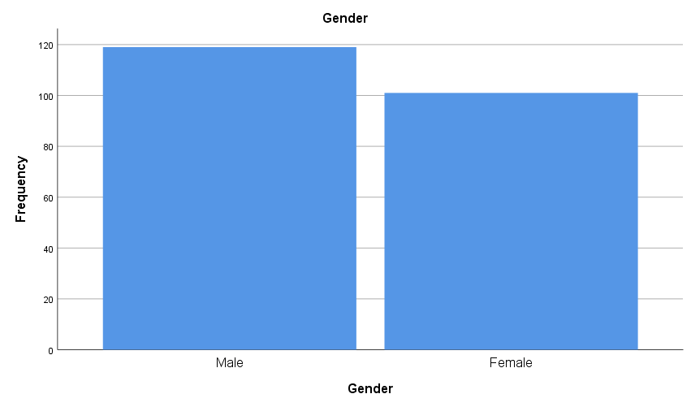

Figure 4.1: Gender

|  |  |  |  |  |  |
| --- | --- | --- | --- | --- | --- |
|  | | Frequency | Percent | Valid Percent | Cumulative Percent |
| Valid | 22-25 year | 27 | 12.3 | 12.3 | 12.3 |
| 26-30 year | 62 | 28.2 | 28.2 | 40.5 |
| 31-35 year | 73 | 33.2 | 33.2 | 73.6 |
| 36-40 year | 35 | 15.9 | 15.9 | 89.5 |
| 40-45 year | 16 | 7.3 | 7.3 | 96.8 |
| above 45 year | 7 | 3.2 | 3.2 | 100.0 |
| Total | 220 | 100.0 | 100.0 |  |

Table 4.2: Age

AI integration in Salesforce CRM reveals a concentration of respondents in the 26-35 year age range, encompassing 61.4% of the total. Specifically, individuals aged 26-30 years represent 28.2%, and those aged 31-35 years make up 33.2%. This suggests the majority of users engaging with AI in CRM are in their late twenties to mid-thirties, indicating a possibly tech-savvy and adaptable demographic. The lesser representation of younger (12.3% for 22-25 years) and older age groups (26.4% for 36 years and above) might reflect varying degrees of exposure to or reliance on AI technologies in CRM systems among different age groups.

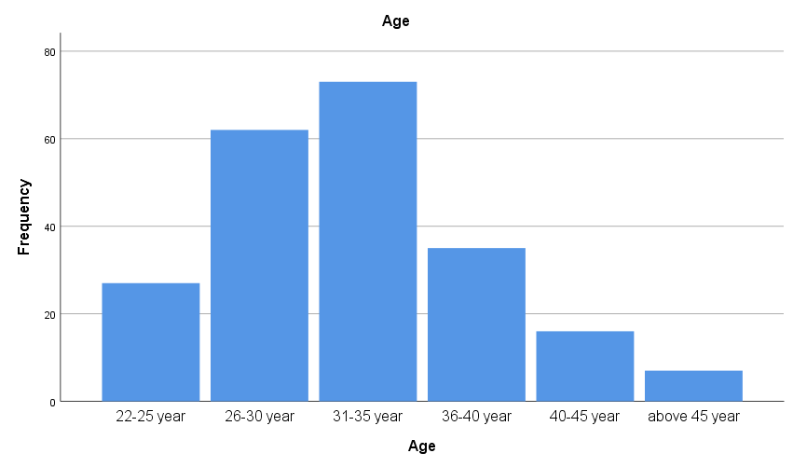

Figure 4.2: Age

|  |  |  |  |  |  |
| --- | --- | --- | --- | --- | --- |
|  | | Frequency | Percent | Valid Percent | Cumulative Percent |
| Valid | Master in Engineering(All Streams) | 64 | 29.1 | 29.1 | 29.1 |
| Bachelor of Engineering(All Streams) | 72 | 32.7 | 32.7 | 61.8 |
| BCA | 25 | 11.4 | 11.4 | 73.2 |
| MCA | 37 | 16.8 | 16.8 | 90.0 |
| Other | 22 | 10.0 | 10.0 | 100.0 |
| Total | 220 | 100.0 | 100.0 |  |

Table 4.3: Qualification

The educational background of participants in the AI integration in Salesforce CRM study predominantly consists of engineering degrees, with 61.8% holding either a Bachelor's (32.7%) or Master's (29.1%) in Engineering across various streams. This dominance suggests a technically proficient cohort, likely comfortable with technology and AI concepts. Participants with a Bachelor of Computer Applications (BCA) and Master of Computer Applications (MCA) represent a significant portion as well, accounting for 11.4% and 16.8% respectively. This further indicates a strong presence of computer science knowledge in the sample. The remaining 10% categorized as 'Other' may include diverse fields, adding to the range of perspectives on AI in CRM systems. The high representation of technically-oriented qualifications suggests a sample well-versed in understanding and assessing AI technologies.

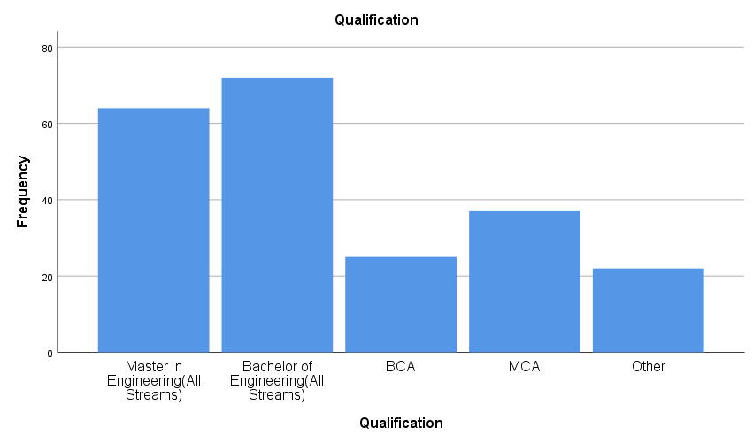

Figure 4.3: Qualification

|  |  |  |  |  |  |
| --- | --- | --- | --- | --- | --- |
|  | | Frequency | Percent | Valid Percent | Cumulative Percent |
| Valid | below 2 year | 20 | 9.1 | 9.1 | 9.1 |
| 2- 5 year | 66 | 30.0 | 30.0 | 39.1 |
| 6-10 year | 45 | 20.5 | 20.5 | 59.5 |
| 11-15 year | 29 | 13.2 | 13.2 | 72.7 |
| 16- 20 year | 50 | 22.7 | 22.7 | 95.5 |
| above 20 year | 10 | 4.5 | 4.5 | 100.0 |
| Total | 220 | 100.0 | 100.0 |  |

Table 4.4: Experience

The experience levels of participants in the study on AI integration in Salesforce CRM are varied, with a notable concentration in the mid-range. Those with 2 to 5 years of experience constitute the largest group at 30%. This is followed by individuals with 16 to 20 years of experience, representing 22.7%, and those with 6 to 10 years at 20.5%. The data indicates a significant presence of moderately experienced professionals, who are likely to be familiar with both traditional and AI-enhanced CRM systems. The lower representation of both early career (9.1% below 2 years) and highly experienced professionals (4.5% above 20 years) might reflect differing levels of adaptability or exposure to AI in professional settings. This diversity in experience levels can provide a comprehensive insight into the impacts and challenges of AI integration in Salesforce CRM across different career stages.

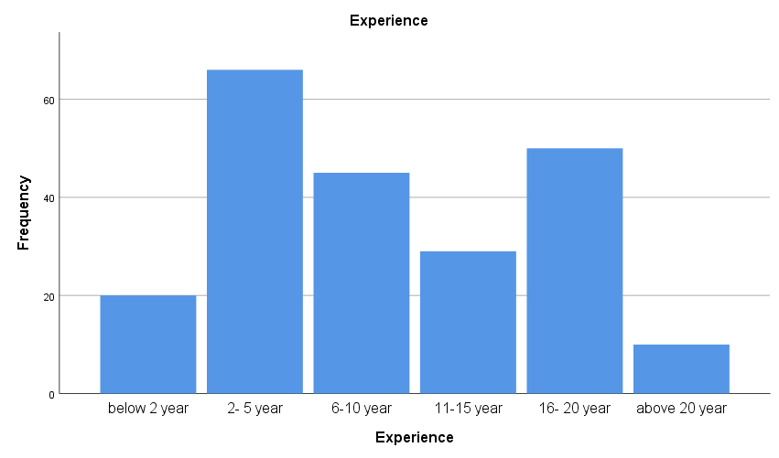

Figure 4.4: Experience

|  |  |  |  |  |  |
| --- | --- | --- | --- | --- | --- |
|  | | Frequency | Percent | Valid Percent | Cumulative Percent |
| Valid | Below 2.5 lacs | 25 | 11.4 | 11.4 | 11.4 |
| above 2.5 lacs -below 5 lacs | 40 | 18.2 | 18.2 | 29.5 |
| above 5 lacs - below 10 lacs | 21 | 9.5 | 9.5 | 39.1 |
| Above 10 lacs | 134 | 60.9 | 60.9 | 100.0 |
| Total | 220 | 100.0 | 100.0 |  |

Table 4.5: Income Tax Slab? (Rupees)

In the study on AI integration in Salesforce CRM, the income data indicates a significant lean towards higher earnings, with 60.9% of respondents earning above 10 lacs, reflecting a predominance of established professionals, possibly in senior roles. Those earning between 2.5 to 5 lacs and below 2.5 lacs constitute 18.2% and 11.4% respectively, while the 5 to 10 lacs bracket is the least represented at 9.5%. This skew towards higher income brackets suggests that the participants are likely experienced and well-placed in their careers, potentially influencing their perspectives on AI in CRM.

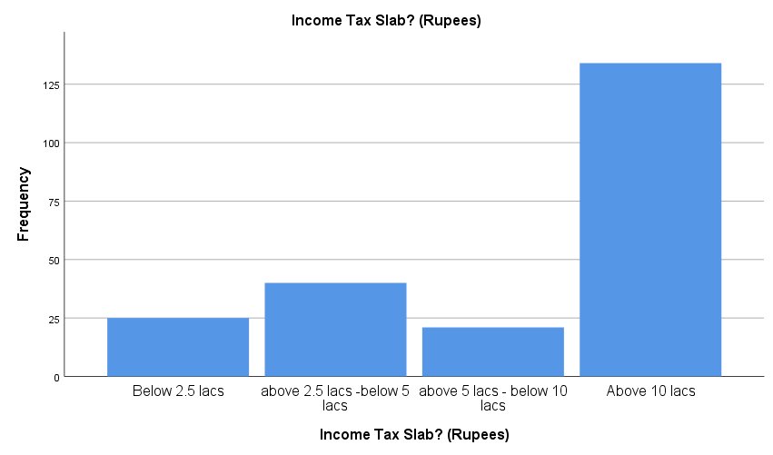

Figure 4.5: Income Tax Slab? (Rupees)

|  |  |  |  |  |  |
| --- | --- | --- | --- | --- | --- |
|  | | Frequency | Percent | Valid Percent | Cumulative Percent |
| Valid | Salesforce developer | 24 | 10.9 | 10.9 | 10.9 |
| Salesforce consultant | 72 | 32.7 | 32.7 | 43.6 |
| Salesforce technical lead | 76 | 34.5 | 34.5 | 78.2 |
| Salesforce architect | 48 | 21.8 | 21.8 | 100.0 |
| Total | 220 | 100.0 | 100.0 |  |

**Table 4.6: Job Role**

The job roles of participants in the study on AI integration in Salesforce CRM are primarily concentrated in advanced and specialized positions. Salesforce Technical Leads form the largest group at 34.5%, followed by Salesforce Consultants at 32.7%. This suggests a strong representation of individuals with significant expertise and decision-making capabilities in the Salesforce ecosystem. Salesforce Architects, another high-level role, comprise 21.8%, further indicating the participation of those with comprehensive understanding of Salesforce infrastructure. Salesforce Developers, while essential to the ecosystem, are the least represented at 10.9%. This distribution underscores the involvement of experienced professionals, likely to offer insightful perspectives on the impact and challenges of AI integration in CRM systems.

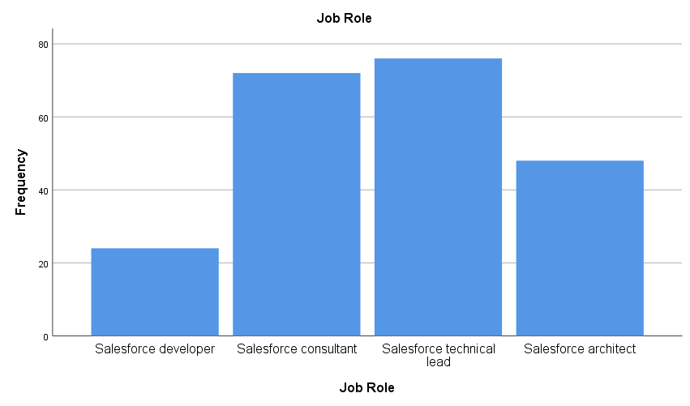

Figure 4.6: Job Role

* 1. **Crosstabulation**

|  |  |  |  |  |  |  |
| --- | --- | --- | --- | --- | --- | --- |
|  | | Which AI feature in Salesforce CRM do you think requires the most immediate refinement, in terms of your satisfaction? | | | | |
| Predictive Analytics | Personalized Recommendations | Automated Task Assignment | Chatbots and Virtual Assistants | Other |
| Gender | Male | 45 | 36 | 8 | 19 | 11 |
| Female | 42 | 30 | 10 | 11 | 8 |
| Total | | 87 | 66 | 18 | 30 | 19 |

Table 4.7: Gender * Which AI feature in Salesforce CRM do you think requires the most immediate refinement, in terms of your satisfaction? Crosstabulation

The questionnaire results reveal gender-based preferences for AI feature refinements in Salesforce CRM. Males predominantly seek improvements in Predictive Analytics (45) and Personalized Recommendations (36), suggesting high engagement with data-driven decision-making tools. Conversely, Automated Task Assignment (8) and Chatbots (19) are less prioritized, indicating either satisfaction with their current state or limited usage. Females also prioritize Predictive Analytics (42) and Personalized Recommendations (30), aligning with males in valuing data-centric features. However, their comparatively lower emphasis on Chatbots and Virtual Assistants (11) and higher on Automated Task Assignment (10) suggests varied interaction patterns or needs in AI tools. These insights are crucial for targeted AI enhancements in Salesforce CRM, enhancing user-centricity and addressing specific gender-based usage patterns.

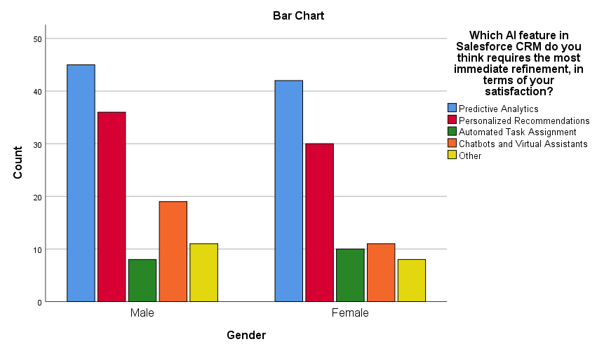

Figure 4.7: Gender * Which AI feature in Salesforce CRM do you think requires the most immediate refinement, in terms of your satisfaction? Crosstabulation

|  |  |  |  |  |  |  |
| --- | --- | --- | --- | --- | --- | --- |
|  | | Which aspect of AI features would you prioritize for improvement, in terms of your satisfaction? | | | | |
| Speed and Responsiveness | Accuracy of Insights | Integration with Other Tools | User Training and Support | Other |
| Gender | Male | 47 | 46 | 10 | 15 | 1 |
| Female | 34 | 39 | 10 | 12 | 6 |
| Total | | 81 | 85 | 20 | 27 | 7 |

Table 4.8 Gender * Which aspect of AI features would you prioritize for improvement, in terms of your satisfaction? Crosstabulation

The survey indicates gender-specific preferences for AI feature improvements in Salesforce CRM. Males predominantly prioritize Speed and Responsiveness (47) and Accuracy of Insights (46), suggesting a strong desire for efficient and reliable AI functionalities. In contrast, Integration with Other Tools (10) and User Training and Support (15) are less of a focus. Females, while also valuing Speed (34) and Accuracy (39), show a notable interest in 'Other' aspects (6), indicating diverse or unaddressed needs. Both genders equally prioritize Integration with Other Tools (10), reflecting a common interest in seamless tool interoperability.

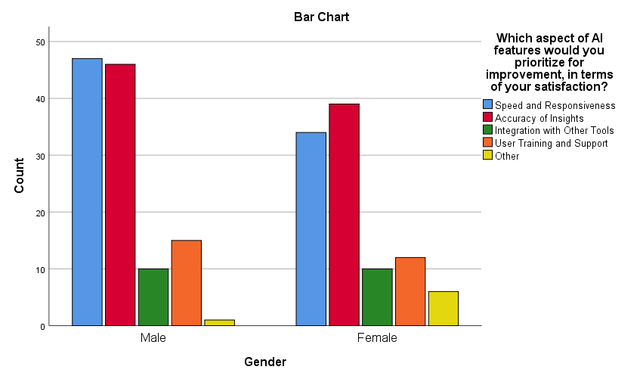

Figure 4.8 Gender * Which aspect of AI features would you prioritize for improvement, in terms of your satisfaction? Crosstabulation

|  |  |  |  |  |  |  |
| --- | --- | --- | --- | --- | --- | --- |
|  | | How satisfied are you with the responsiveness of the AI components within Salesforce CRM? | | | | |
| Strongly Satisfied | Satisfied | Neutra | Dissatisfied | Strongly Dissatisfied |
| Gender | Male | 37 | 28 | 26 | 18 | 10 |
| Female | 27 | 32 | 17 | 17 | 8 |
| Total | | 64 | 60 | 43 | 35 | 18 |

Table 4.9: Gender * How satisfied are you with the responsiveness of the AI components within Salesforce CRM? Crosstabulation

results show differing levels of satisfaction with the responsiveness of AI components in Salesforce CRM among genders. Males report higher strong satisfaction (37) but also greater dissatisfaction (28 combined for Dissatisfied and Strongly Dissatisfied) compared to females. Females, on the other hand, show a more balanced view, with a higher number feeling generally satisfied (32) but fewer strongly satisfied (27). Both genders have a significant portion of respondents indicating neutrality, suggesting ambivalence or lack of strong opinion about the AI responsiveness

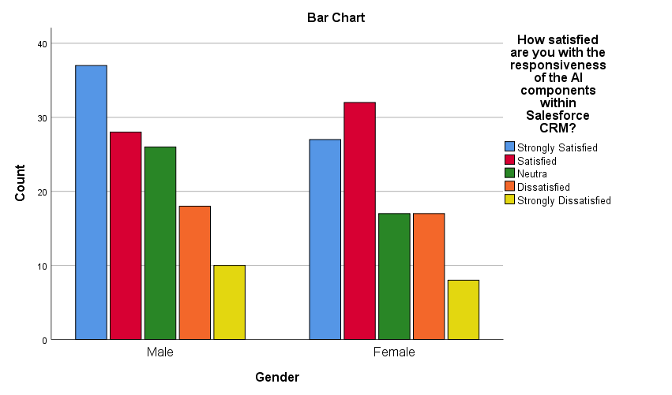

Figure 4.9: Gender * How satisfied are you with the responsiveness of the AI components within Salesforce CRM? Crosstabulation

|  |  |  |  |  |  |  |
| --- | --- | --- | --- | --- | --- | --- |
|  | | How satisfied are you with the frequency of encountering issues or errors when using AI features in Salesforce CRM? | | | | |
| Strongly Satisfied | Satisfied | Neutra | Dissatisfied | Strongly Dissatisfied |
| Gender | Male | 43 | 40 | 7 | 22 | 7 |
| Female | 26 | 35 | 8 | 20 | 12 |
| Total | | 69 | 75 | 15 | 42 | 19 |

Table 4.10: Gender * How satisfied are you with the frequency of encountering issues or errors when using AI features in Salesforce CRM? Crosstabulation

Salesforce CRM shows gender-specific responses. Males generally express higher satisfaction (43 Strongly Satisfied, 40 Satisfied) concerning the frequency of encountering issues, suggesting a relatively smooth experience. However, there's also a significant portion (29 combined) who are dissatisfied or strongly dissatisfied, indicating room for improvement in AI stability or error management. Females, in contrast, show lower levels of strong satisfaction (26) but a comparable level of general satisfaction (35) to males. Notably, there's a higher count of strong dissatisfaction among females (12), highlighting a more critical view of AI feature reliability. Both genders have a minority of neutral responses (males 7, females 8), reflecting a definitive opinion on this aspect

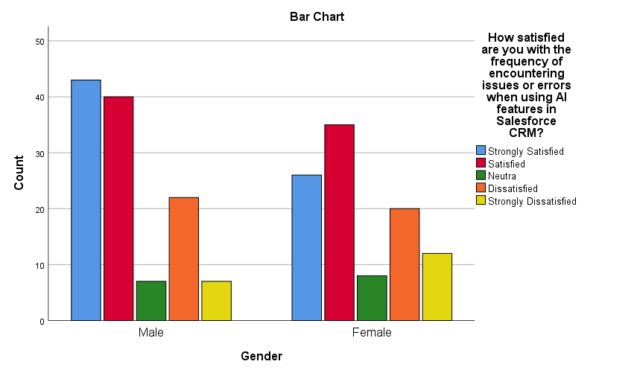

Figure 4.10: Gender * How satisfied are you with the frequency of encountering issues or errors when using AI features in Salesforce CRM? Crosstabulation

|  |  |  |  |  |  |  |
| --- | --- | --- | --- | --- | --- | --- |
|  | | How satisfied are you with the relevance of the recommendations or insights provided by AI-driven personalization in Salesforce CRM? | | | | |
| Strongly Satisfied | Satisfied | Neutra | Dissatisfied | Strongly Dissatisfied |
| Gender | Male | 42 | 44 | 10 | 16 | 7 |
| Female | 38 | 35 | 6 | 14 | 8 |
| Total | | 80 | 79 | 16 | 30 | 15 |

Table 4.11: Gender * How satisfied are you with the relevance of the recommendations or insights provided by AI-driven personalization in Salesforce CRM? Crosstabulation

Salesforce CRM indicate gender-based perceptions. Males demonstrate a high level of satisfaction, with 42 strongly satisfied and 44 satisfied with the relevance of recommendations or insights. However, there's a noticeable dissatisfied group (23 combined for Dissatisfied and Strongly Dissatisfied), suggesting some shortcomings in AI personalization for a segment of male users. Females also show substantial satisfaction (38 Strongly Satisfied, 35 Satisfied) but have a slightly higher rate of strong dissatisfaction (8) compared to males. The lower neutral responses (6) among females suggest that most have a clear stance on the AI's effectiveness in personalization.

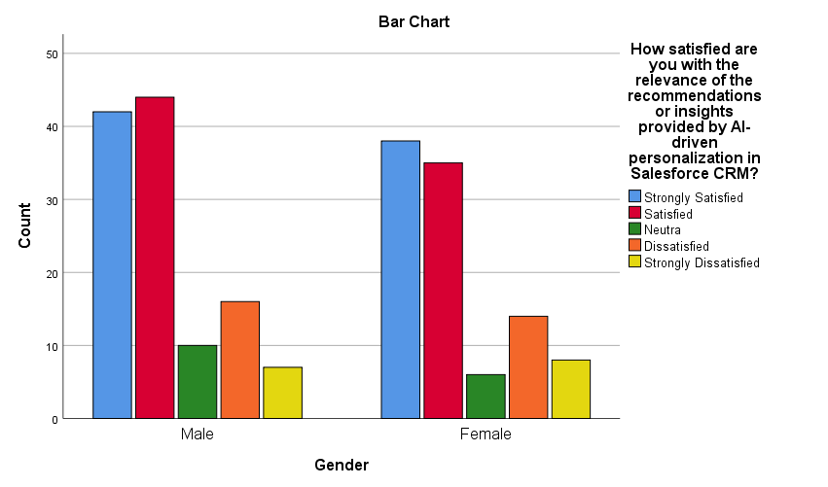

Figure 4.11: Gender * How satisfied are you with the relevance of the recommendations or insights provided by AI-driven personalization in Salesforce CRM? Crosstabulation

|  |  |  |  |  |  |  |
| --- | --- | --- | --- | --- | --- | --- |
|  | | How satisfied are you that AI-driven personalization enhances your engagement with the CRM system? | | | | |
| Strongly Satisfied | Satisfied | Neutra | Dissatisfied | Strongly Dissatisfied |
| Gender | Male | 42 | 33 | 8 | 18 | 18 |
| Female | 36 | 32 | 13 | 13 | 7 |
| Total | | 78 | 65 | 21 | 31 | 25 |

Table 4.12: Gender * How satisfied are you that AI-driven personalization enhances your engagement with the CRM system? Crosstabulation

AI-driven personalization on engagement with the CRM system, gender-specific satisfaction levels vary. Males show a significant positive response, with 42 strongly satisfied and 33 satisfied, indicating a general perception that AI personalization positively influences their CRM engagement. However, there's an equal number (18 each) of males who are dissatisfied or strongly dissatisfied, suggesting a notable segment feels the personalization doesn't enhance their experience. Females, while also leaning towards satisfaction (36 strongly satisfied, 32 satisfied), exhibit a lower level of strong dissatisfaction (7) compared to males. Additionally, a higher proportion of females (13) are neutral, indicating ambivalence or uncertainty about the impact of AI personalization on their engagement.

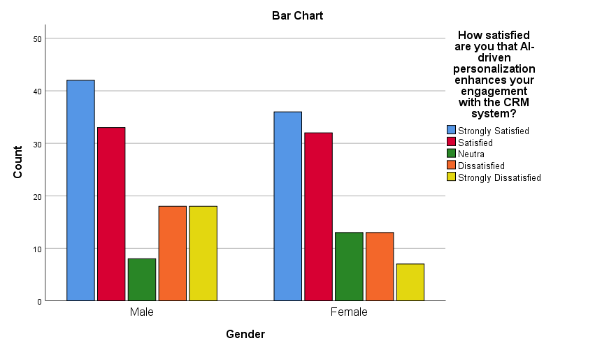

Figure 4.12: Gender * How satisfied are you that AI-driven personalization enhances your engagement with the CRM system? Crosstabulation

|  |  |  |  |  |  |  |
| --- | --- | --- | --- | --- | --- | --- |
|  | | Which AI feature in Salesforce CRM do you think requires the most immediate refinement, in terms of your satisfaction? | | | | |
| Predictive Analytics | Personalized Recommendations | Automated Task Assignment | Chatbots and Virtual Assistants | Other |
| Age | 22-25 year | 10 | 10 | 2 | 4 | 1 |
| 26-30 year | 19 | 20 | 8 | 9 | 6 |
| 31-35 year | 30 | 20 | 5 | 11 | 7 |
| 36-40 year | 18 | 9 | 2 | 4 | 2 |
| 40-45 year | 9 | 3 | 0 | 2 | 2 |
| above 45 year | 1 | 4 | 1 | 0 | 1 |
| Total | | 87 | 66 | 18 | 30 | 19 |

Table 4.13: Age * Which AI feature in Salesforce CRM do you think requires the most immediate refinement, in terms of your satisfaction? Crosstabulation

AI feature refinement in Salesforce CRM across different age groups show distinct preferences. Participants aged 22-25 years equally prioritize Predictive Analytics and Personalized Recommendations (10 each), with lesser focus on Automated Task Assignment (2). The 26-30 year age group exhibits a similar trend, favoring Predictive Analytics (19) and Personalized Recommendations (20), but with greater interest in Automated Task Assignment (8). Those aged 31-35 years show a strong preference for Predictive Analytics (30) over Personalized Recommendations (20). The 36-40 year cohort's interest wanes, with only 18 favoring Predictive Analytics and 9 for Personalized Recommendations. Participants aged 40-45 years exhibit minimal demand, with only 9 for Predictive Analytics and 3 for Recommendations. Those above 45 years show the least interest, with only 1 for Predictive Analytics. This data highlights the varying emphasis on AI features with age, pointing to a need for age-appropriate AI feature enhancements in Salesforce CRM.

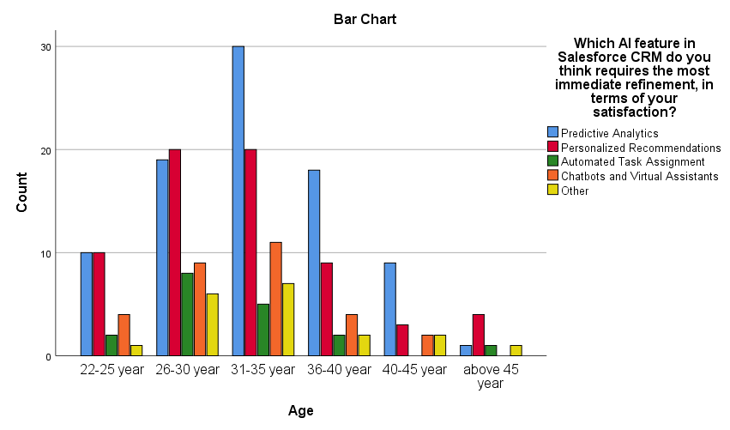

Figure 4.13: Age * Which AI feature in Salesforce CRM do you think requires the most immediate refinement, in terms of your satisfaction? Crosstabulation

|  |  |  |  |  |  |  |
| --- | --- | --- | --- | --- | --- | --- |
|  | | Which aspect of AI features would you prioritize for improvement, in terms of your satisfaction? | | | | |
| Speed and Responsiveness | Accuracy of Insights | Integration with Other Tools | User Training and Support | Other |
| Age | 22-25 year | 8 | 12 | 2 | 4 | 1 |
| 26-30 year | 23 | 27 | 7 | 3 | 2 |
| 31-35 year | 31 | 23 | 6 | 10 | 3 |
| 36-40 year | 11 | 15 | 3 | 6 | 0 |
| 40-45 year | 5 | 5 | 2 | 4 | 0 |
| above 45 year | 3 | 3 | 0 | 0 | 1 |
| Total | | 81 | 85 | 20 | 27 | 7 |

Table 4.14: Age * Which aspect of AI features would you prioritize for improvement, in terms of your satisfaction? Crosstabulation

AI feature improvements in Salesforce CRM, segmented by age, reveals varying preferences. The 22-25 year age group leans towards Accuracy of Insights (12) over Speed and Responsiveness (8), with limited interest in Integration with Other Tools (2). Those aged 26-30 years show a higher preference for Speed and Responsiveness (23) and Accuracy of Insights (27), indicating a desire for efficient and accurate AI functionalities. The 31-35 year cohort also values Speed and Responsiveness (31) highly, followed by Accuracy of Insights (23), and shows notable interest in User Training and Support (10). The 36-40 year group's priorities are more balanced between Speed and Responsiveness (11) and Accuracy of Insights (15). Participants aged 40-45 years exhibit an equal but minimal preference for Speed and Responsiveness, and Accuracy of Insights (5 each). The group above 45 years shows the least interest, with minimal preference for Speed and Responsiveness, and Accuracy of Insights (3 each).

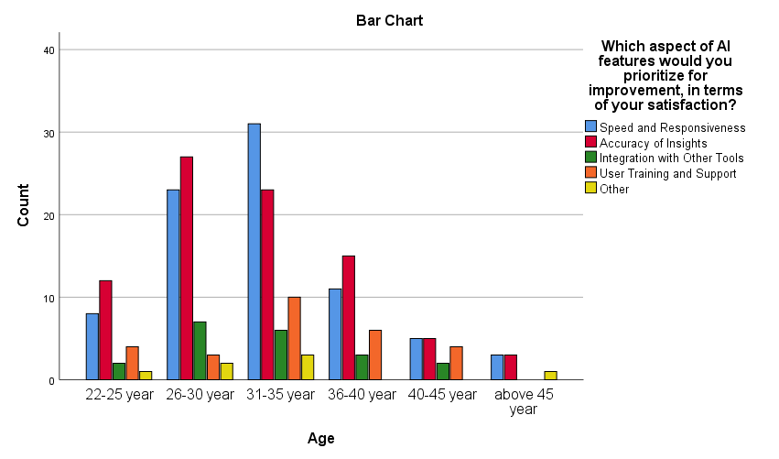

Figure 4.14: Age * Which aspect of AI features would you prioritize for improvement, in terms of your satisfaction? Crosstabulation

|  |  |  |  |  |  |  |
| --- | --- | --- | --- | --- | --- | --- |
|  | | If Salesforce CRM were to focus on one area for improvement in its AI integration, which area would you prefer? | | | | |
| Advanced Capabilities and Features | User Interface and Friendliness | Feedback Mechanism and Responsiveness | Integration with Other Systems and Tools | Natural Language Processing (NLP) for Conversational Interfaces |
| Age | 22-25 year | 5 | 14 | 2 | 6 | 0 |
| 26-30 year | 25 | 20 | 5 | 5 | 7 |
| 31-35 year | 21 | 31 | 3 | 13 | 5 |
| 36-40 year | 15 | 9 | 1 | 10 | 0 |
| 40-45 year | 6 | 5 | 1 | 2 | 2 |
| above 45 year | 5 | 1 | 0 | 1 | 0 |
| Total | | 77 | 80 | 12 | 37 | 14 |

Table 4.15: Age * If Salesforce CRM were to focus on one area for improvement in its AI integration, which area would you prefer? Crosstabulation

AI integration improvement in Salesforce CRM, categorized by age, shows varied priorities. Participants aged 22-25 years prioritize User Interface and Friendliness (14) over Advanced Capabilities and Features (5), suggesting a desire for a more user-friendly experience. The 26-30 year age group leans towards Advanced Capabilities and Features (25) and also shows a significant interest in User Interface and Friendliness (20), indicating a balance between advanced functionality and ease of use. Those in the 31-35 year bracket show a strong preference for User Interface and Friendliness (31) and also value Advanced Capabilities (21), emphasizing the importance of intuitive design. The 36-40 year group prefers Advanced Capabilities and Features (15) but with a reduced focus on User Interface (9). Participants aged 40-45 years show an even lower demand, with a slight preference for Advanced Capabilities (6) over User Interface (5). Those above 45 years demonstrate the least interest, with a minimal preference for Advanced Capabilities (5) and very little for User Interface (1).

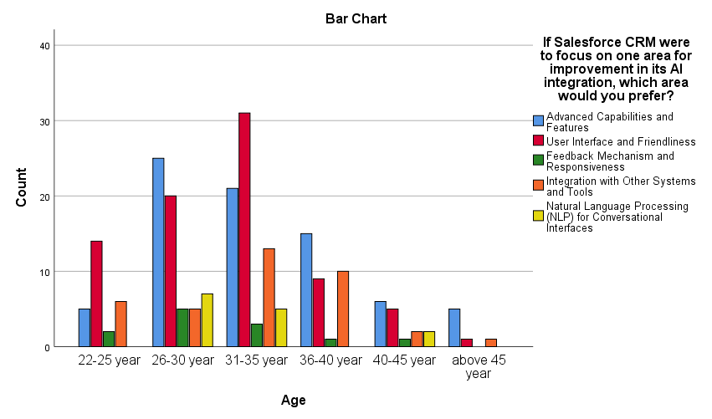

Figure 4.15: Age * If Salesforce CRM were to focus on one area for improvement in its AI integration, which area would you prefer? Crosstabulation

|  |  |  |  |  |  |  |
| --- | --- | --- | --- | --- | --- | --- |
|  | | How would you rate the intuitiveness of the user interface of AI-integrated features in Salesforce CRM? | | | | |
| Highly Intuitive | Moderately Intuitive | Neutral | Somewhat Confusing | Very Confusing |
| Age | 22-25 year | 10 | 10 | 1 | 6 | 0 |
| 26-30 year | 31 | 16 | 4 | 9 | 2 |
| 31-35 year | 23 | 26 | 7 | 12 | 5 |
| 36-40 year | 14 | 13 | 1 | 4 | 3 |
| 40-45 year | 6 | 4 | 1 | 2 | 3 |
| above 45 year | 2 | 5 | 0 | 0 | 0 |
| Total | | 86 | 74 | 14 | 33 | 13 |

Table 4.16: Age * How would you rate the intuitiveness of the user interface of AI-integrated features in Salesforce CRM? Crosstabulation

AI-integrated features in Salesforce CRM, broken down by age, show a range of perceptions. Younger users (22-25 years) are evenly split in finding the interface Highly or Moderately Intuitive (10 each), with a smaller number finding it Somewhat Confusing (6). The 26-30 year age group leans more towards finding it Highly Intuitive (31), though some find it Moderately Intuitive (16) or even Somewhat Confusing (9). Users aged 31-35 years also predominantly find the interface Highly Intuitive (23) or Moderately Intuitive (26), but a notable number find it Confusing (17 combined for Somewhat and Very Confusing). The 36-40 year group's responses are balanced between Highly Intuitive (14) and Moderately Intuitive (13), with fewer finding it confusing. The 40-45 year age group has a lower overall perception of intuitiveness (6 Highly Intuitive, 4 Moderately Intuitive) and some confusion (5 combined). Participants above 45 years, though few in number, mostly find the interface Moderately Intuitive (5).

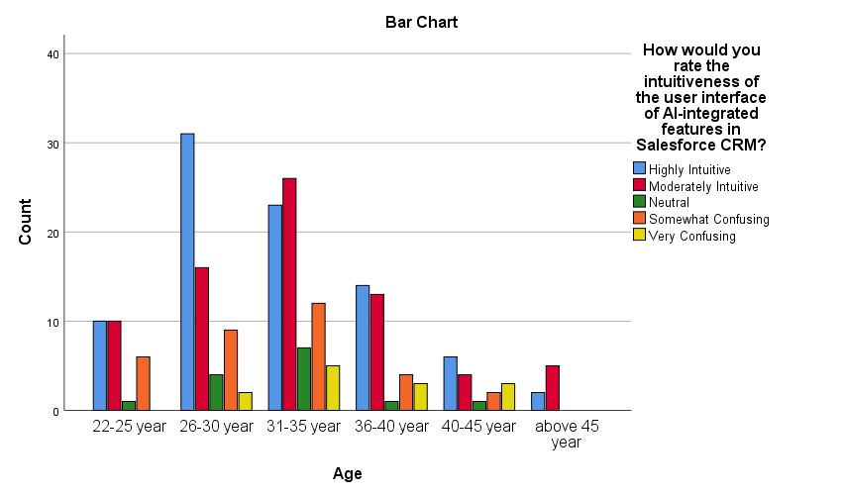

Figure 4.16: Age * How would you rate the intuitiveness of the user interface of AI-integrated features in Salesforce CRM? Crosstabulation

|  |  |  |  |  |  |  |
| --- | --- | --- | --- | --- | --- | --- |
|  | | How satisfied are you with the responsiveness of the AI components within Salesforce CRM? | | | | |
| Strongly Satisfied | Satisfied | Neutra | Dissatisfied | Strongly Dissatisfied |
| Age | 22-25 year | 9 | 8 | 3 | 7 | 0 |
| 26-30 year | 24 | 12 | 15 | 7 | 4 |
| 31-35 year | 19 | 19 | 15 | 10 | 10 |
| 36-40 year | 8 | 13 | 6 | 6 | 2 |
| 40-45 year | 2 | 7 | 3 | 3 | 1 |
| above 45 year | 2 | 1 | 1 | 2 | 1 |
| Total | | 64 | 60 | 43 | 35 | 18 |

Table 4.17: Age * How satisfied are you with the responsiveness of the AI components within Salesforce CRM? Crosstabulation

AI components in Salesforce CRM, segmented by age, reveals varied levels of satisfaction. The 22-25 year age group shows a moderate satisfaction, with 9 strongly satisfied and 8 satisfied, but with a small number dissatisfied (7). The 26-30 year age group displays a more divided view, with 24 strongly satisfied but also a significant neutral stance (15) and some dissatisfaction (11 combined for Dissatisfied and Strongly Dissatisfied). Those aged 31-35 years exhibit an evenly spread opinion, with equal numbers (19 each) for strongly satisfied and satisfied, but also notable dissatisfaction (20 combined). The 36-40 year group presents a more balanced view, with 8 strongly satisfied and 13 satisfied, but also some dissatisfaction (8 combined). Participants aged 40-45 years and above 45 years show lower levels of satisfaction (2 strongly satisfied in each group) and a small number of dissatisfied users.

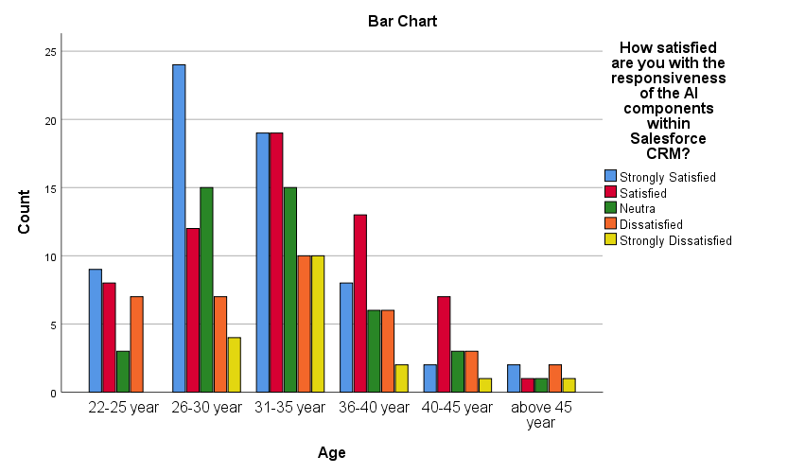

Figure 4.17: Age * How satisfied are you with the responsiveness of the AI components within Salesforce CRM? Crosstabulation

|  |  |  |  |  |  |  |
| --- | --- | --- | --- | --- | --- | --- |
|  | | How satisfied are you with the way AI features in Salesforce CRM understand and cater to your requests or queries? | | | | |
| Strongly Satisfied | Satisfied | Neutra | Dissatisfied | Strongly Dissatisfied |
| Age | 22-25 year | 9 | 9 | 3 | 3 | 3 |
| 26-30 year | 31 | 16 | 3 | 7 | 5 |
| 31-35 year | 17 | 21 | 7 | 15 | 13 |
| 36-40 year | 13 | 12 | 3 | 3 | 4 |
| 40-45 year | 5 | 6 | 3 | 2 | 0 |
| above 45 year | 3 | 2 | 0 | 2 | 0 |
| Total | | 78 | 66 | 19 | 32 | 25 |

Table 4.18: Age * How satisfied are you with the way AI features in Salesforce CRM understand and cater to your requests or queries? Crosstabulation

AI features in Salesforce CRM understand and cater to user requests or queries, segmented by age, shows diverse responses. Users aged 22-25 years are moderately satisfied (9 strongly satisfied, 9 satisfied), but there's an equal distribution across neutral and dissatisfied categories (3 each). The 26-30 year group appears more content, with a higher number of strongly satisfied (31) but also some dissatisfaction (12 combined). For those aged 31-35 years, satisfaction is mixed (17 strongly satisfied, 21 satisfied), contrasted with a significant level of dissatisfaction (28 combined). The 36-40 year age group shows a fair level of satisfaction (13 strongly satisfied, 12 satisfied), with fewer dissatisfied users (7 combined). Participants aged 40-45 years have a moderate satisfaction level (5 strongly satisfied, 6 satisfied) and minimal dissatisfaction. Those above 45 years, albeit fewer, show a slight leaning towards satisfaction (3 strongly satisfied, 2 satisfied) with some dissatisfaction (2).

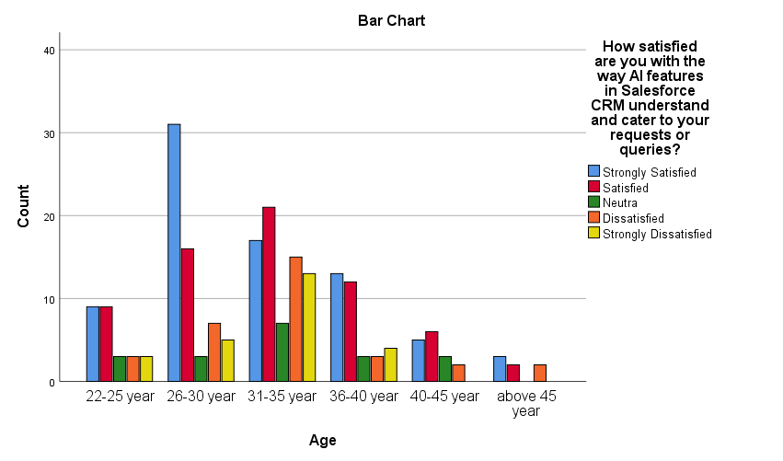

Figure 4.18: Age * How satisfied are you with the way AI features in Salesforce CRM understand and cater to your requests or queries? Crosstabulation

|  |  |  |  |  |  |  |
| --- | --- | --- | --- | --- | --- | --- |
|  | | Which AI feature in Salesforce CRM do you think requires the most immediate refinement, in terms of your satisfaction? | | | | |
| Predictive Analytics | Personalized Recommendations | Automated Task Assignment | Chatbots and Virtual Assistants | Other |
| Qualification | Master in Engineering(All Streams) | 22 | 20 | 6 | 10 | 6 |
| Bachelor of Engineering(All Streams) | 32 | 20 | 5 | 8 | 7 |
| BCA | 8 | 11 | 1 | 3 | 2 |
| MCA | 16 | 11 | 2 | 5 | 3 |
| Other | 9 | 4 | 4 | 4 | 1 |
| Total | | 87 | 66 | 18 | 30 | 19 |

Table 4.19: Qualification * Which AI feature in Salesforce CRM do you think requires the most immediate refinement, in terms of your satisfaction? Crosstabulation

AI features in Salesforce CRM reveals a consistent preference across educational backgrounds. Both Master and Bachelor of Engineering degree holders prioritize the refinement of Predictive Analytics (22 and 32 responses, respectively), closely followed by Personalized Recommendations. This suggests a technical perspective favoring advanced analytical capabilities. BCA and MCA graduates also see Predictive Analytics and Personalized Recommendations as key areas for improvement, though BCA holders show a slightly higher inclination towards Personalized Recommendations.

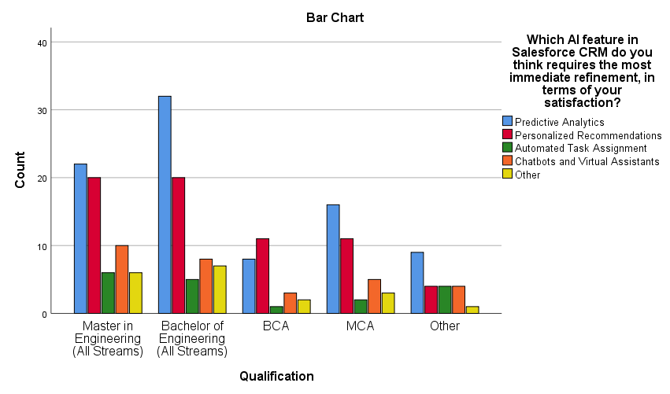

Figure 4.19: Qualification * Which AI feature in Salesforce CRM do you think requires the most immediate refinement, in terms of your satisfaction? Crosstabulation

|  |  |  |  |  |  |  |
| --- | --- | --- | --- | --- | --- | --- |
|  | | Which aspect of AI features would you prioritize for improvement, in terms of your satisfaction? | | | | |
| Speed and Responsiveness | Accuracy of Insights | Integration with Other Tools | User Training and Support | Other |
| Qualification | Master in Engineering(All Streams) | 18 | 30 | 8 | 6 | 2 |
| Bachelor of Engineering(All Streams) | 28 | 27 | 7 | 7 | 3 |
| BCA | 13 | 5 | 1 | 5 | 1 |
| MCA | 16 | 14 | 1 | 6 | 0 |
| Other | 6 | 9 | 3 | 3 | 1 |
| Total | | 81 | 85 | 20 | 27 | 7 |

Table 4.20: Qualification * Which aspect of AI features would you prioritize for improvement, in terms of your satisfaction? Crosstabulation

AI feature improvement priorities by qualification, the data reveals varied emphases. For Master's in Engineering, the highest priority is Accuracy of Insights (30), followed by Speed and Responsiveness (18). Bachelor of Engineering holders also prioritize Accuracy of Insights (27) but place greater emphasis on Speed and Responsiveness (28). BCA graduates, on the other hand, show a distinct preference for Speed and Responsiveness (13), with Accuracy of Insights (5) being less of a priority. MCA degree holders have a balanced view, favoring Speed and Responsiveness (16) slightly more than Accuracy of Insights (14). Those with 'Other' qualifications give a moderate importance to Accuracy of Insights (9) and Speed and Responsiveness (6). Across all groups, Integration with Other Tools and User Training and Support are less prioritized, with single-digit responses (ranging from 1 to 8 and 0 to 7, respectively). This data highlights differing priorities based on educational background, with a general consensus on the importance of speed and accuracy

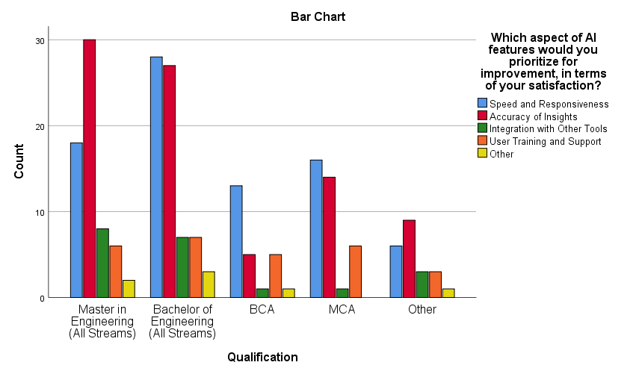

Figure 4.20: Qualification * Which aspect of AI features would you prioritize for improvement, in terms of your satisfaction? Crosstabulation

|  |  |  |  |  |  |  |
| --- | --- | --- | --- | --- | --- | --- |
|  | | If Salesforce CRM were to focus on one area for improvement in its AI integration, which area would you prefer? | | | | |
| Advanced Capabilities and Features | User Interface and Friendliness | Feedback Mechanism and Responsiveness | Integration with Other Systems and Tools | Natural Language Processing (NLP) for Conversational Interfaces |
| Qualification | Master in Engineering(All Streams) | 23 | 25 | 7 | 6 | 3 |
| Bachelor of Engineering(All Streams) | 23 | 27 | 4 | 14 | 4 |
| BCA | 8 | 8 | 1 | 5 | 3 |
| MCA | 13 | 13 | 0 | 9 | 2 |
| Other | 10 | 7 | 0 | 3 | 2 |
| Total | | 77 | 80 | 12 | 37 | 14 |

Table 4.21: Qualification * If Salesforce CRM were to focus on one area for improvement in its AI integration, which area would you prefer? Crosstabulation

AI integration improvement in Salesforce CRM by qualification, distinct preferences emerge. For Master's in Engineering holders, the top preferences are nearly tied between Advanced Capabilities and Features (23) and User Interface and Friendliness (25). Bachelor of Engineering graduates also show a similar pattern, valuing User Interface and Friendliness slightly more (27) compared to Advanced Capabilities and Features (23), but they uniquely emphasize Integration with Other Systems and Tools (14). BCA degree holders evenly prioritize Advanced Capabilities and Features and User Interface and Friendliness (8 each). MCA graduates show an equal preference for Advanced Capabilities and Features and User Interface and Friendliness (13 each), with a notable inclination towards Integration with Other Systems and Tools (9). Those with 'Other' qualifications lean towards Advanced Capabilities and Features (10) over User Interface and Friendliness (7).

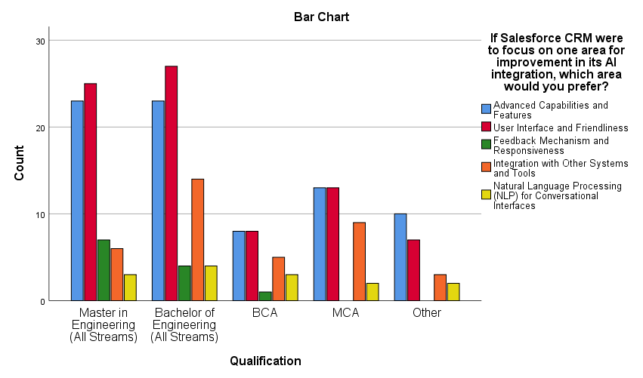

Figure 4.21: Qualification * If Salesforce CRM were to focus on one area for improvement in its AI integration, which area would you prefer? Crosstabulation

|  |  |  |  |  |  |  |
| --- | --- | --- | --- | --- | --- | --- |
|  | | How would you rate the intuitiveness of the user interface of AI-integrated features in Salesforce CRM? | | | | |
| Highly Intuitive | Moderately Intuitive | Neutral | Somewhat Confusing | Very Confusing |
| Qualification | Master in Engineering(All Streams) | 23 | 24 | 4 | 10 | 3 |
| Bachelor of Engineering(All Streams) | 25 | 28 | 4 | 11 | 4 |
| BCA | 12 | 4 | 2 | 4 | 3 |
| MCA | 19 | 12 | 1 | 4 | 1 |
| Other | 7 | 6 | 3 | 4 | 2 |
| Total | | 86 | 74 | 14 | 33 | 13 |

Table 4.21: Qualification * How would you rate the intuitiveness of the user interface of AI-integrated features in Salesforce CRM? Crosstabulation

AI-integrated features in Salesforce CRM by qualification, varying responses emerge. Master's in Engineering respondents predominantly rate the interface as intuitive (23 highly intuitive, 24 moderately intuitive), though some experience confusion (13 somewhat or very confusing). Bachelor of Engineering holders show a similar trend, with a majority finding the interface intuitive (25 highly, 28 moderately), but a noticeable group finds it confusing (15 somewhat or very confusing). BCA graduates present a more polarized view, with 12 rating it as highly intuitive and another 7 finding it confusing. MCA degree holders also lean towards finding the interface intuitive (19 highly, 12 moderately), with fewer experiencing confusion (5). Those with 'Other' qualifications exhibit a balanced perspective, with 7 finding it intuitive and 6 experiencing confusion.

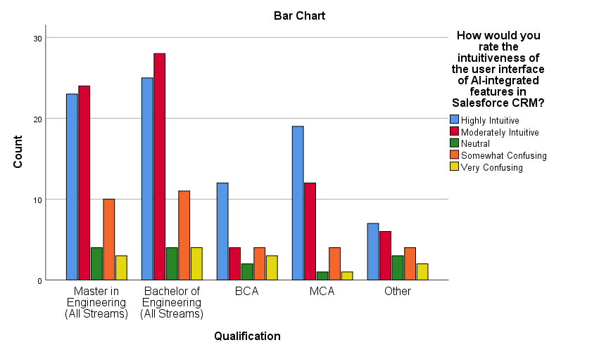

Figure 4.21: Qualification * How would you rate the intuitiveness of the user interface of AI-integrated features in Salesforce CRM? Crosstabulation

|  |  |  |  |  |  |  |
| --- | --- | --- | --- | --- | --- | --- |
|  | | How satisfied are you with the responsiveness of the AI components within Salesforce CRM? | | | | |
| Strongly Satisfied | Satisfied | Neutra | Dissatisfied | Strongly Dissatisfied |
| Qualification | Master in Engineering(All Streams) | 15 | 16 | 14 | 11 | 8 |
| Bachelor of Engineering(All Streams) | 16 | 21 | 16 | 16 | 3 |
| BCA | 10 | 4 | 6 | 1 | 4 |
| MCA | 14 | 13 | 4 | 4 | 2 |
| Other | 9 | 6 | 3 | 3 | 1 |
| Total | | 64 | 60 | 43 | 35 | 18 |

Table 4.22: Qualification * How satisfied are you with the responsiveness of the AI components within Salesforce CRM? Crosstabulation

AI components in Salesforce CRM, differentiated by qualification, there's a varied spectrum of responses. Master of Engineering graduates exhibit a diverse range of sentiments, with 15 strongly satisfied and 8 strongly dissatisfied, indicating polarized views. Bachelor of Engineering holders show a similar pattern, with a slightly higher satisfaction (16 strongly satisfied) and fewer instances of strong dissatisfaction (3). BCA graduates, however, demonstrate a leaning towards satisfaction (10 strongly satisfied), but also a notable proportion of strong dissatisfaction (4). MCA degree holders display a tilt towards satisfaction (14 strongly satisfied) with minimal strong dissatisfaction (2). Those with 'Other' qualifications predominantly express satisfaction (9 strongly satisfied), with a single instance of strong dissatisfaction.

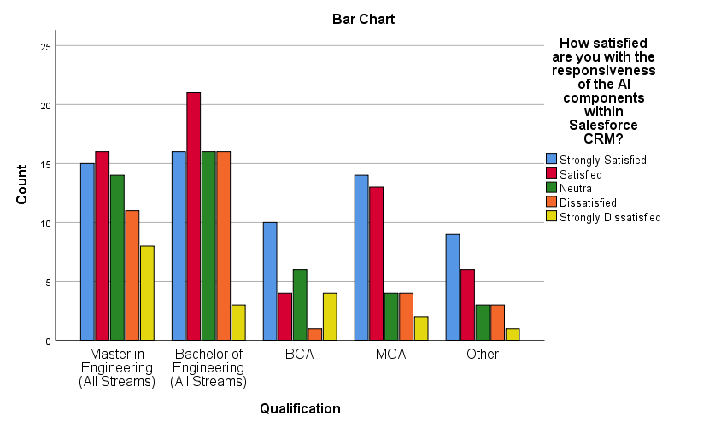

Figure 4.22: Qualification * How satisfied are you with the responsiveness of the AI components within Salesforce CRM? Crosstabulation

|  |  |  |  |  |  |  |
| --- | --- | --- | --- | --- | --- | --- |
|  | | How satisfied are you with the way AI features in Salesforce CRM understand and cater to your requests or queries? | | | | |
| Strongly Satisfied | Satisfied | Neutra | Dissatisfied | Strongly Dissatisfied |
| Experience | below 2 year | 8 | 6 | 1 | 3 | 2 |
| 2- 5 year | 29 | 19 | 5 | 8 | 5 |
| 6-10 year | 14 | 11 | 3 | 9 | 8 |
| 11-15 year | 8 | 9 | 3 | 5 | 4 |
| 16- 20 year | 16 | 18 | 4 | 6 | 6 |
| above 20 year | 3 | 3 | 3 | 1 | 0 |
| Total | | 78 | 66 | 19 | 32 | 25 |

Table 4.23: Experience * How satisfied are you with the way AI features in Salesforce CRM understand and cater to your requests or queries? Crosstabulation

AI features in Salesforce CRM understand and cater to requests or queries, when cross-tabulated with experience, show diverse responses. For those with less than 2 years of experience, the majority are satisfied (8 strongly satisfied, 6 satisfied), but some dissatisfaction is present (5). In the 2-5 year experience bracket, there's a clear leaning towards satisfaction (29 strongly satisfied, 19 satisfied), though dissatisfaction is also notable (13). Those with 6-10 years of experience show a more balanced perspective, with 14 strongly satisfied but also a higher level of dissatisfaction (17). Participants with 11-15 years of experience are generally satisfied (8 strongly satisfied, 9 satisfied) but also express some dissatisfaction (9). The 16-20 year group displays a similar trend (16 strongly satisfied, 18 satisfied) with a moderate level of dissatisfaction (12). Interestingly, those with over 20 years of experience have a varied but mostly positive response (3 strongly satisfied, 3 satisfied), with minimal dissatisfaction.

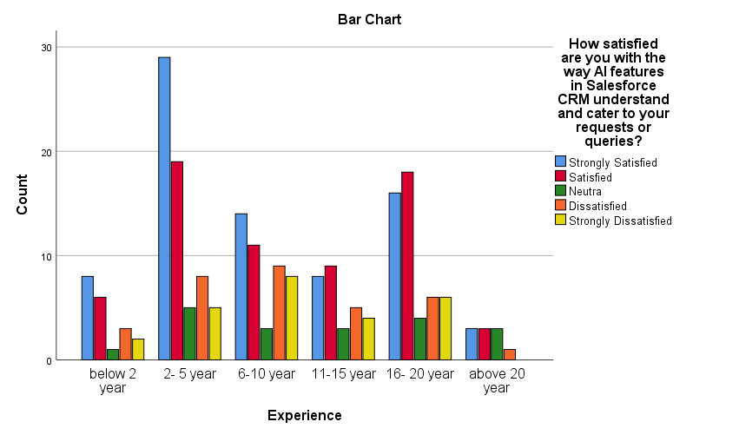

Figure 4.23: Experience * How satisfied are you with the way AI features in Salesforce CRM understand and cater to your requests or queries? Crosstabulation

|  |  |  |  |  |  |  |
| --- | --- | --- | --- | --- | --- | --- |
|  | | How satisfied are you with the frequency of encountering issues or errors when using AI features in Salesforce CRM? | | | | |
| Strongly Satisfied | Satisfied | Neutra | Dissatisfied | Strongly Dissatisfied |
| Experience | below 2 year | 7 | 6 | 2 | 3 | 2 |
| 2- 5 year | 21 | 20 | 1 | 17 | 7 |
| 6-10 year | 13 | 18 | 4 | 8 | 2 |
| 11-15 year | 7 | 11 | 1 | 8 | 2 |
| 16- 20 year | 19 | 16 | 6 | 5 | 4 |
| above 20 year | 2 | 4 | 1 | 1 | 2 |
| Total | | 69 | 75 | 15 | 42 | 19 |

Figure 4.24: Experience * How satisfied are you with the frequency of encountering issues or errors when using AI features in Salesforce CRM? Crosstabulation

AI features in Salesforce CRM, based on experience, reveals a range of responses. For individuals with less than 2 years of experience, there's a moderate satisfaction (7 strongly satisfied, 6 satisfied), but issues are noted (5 dissatisfied or strongly dissatisfied). Those with 2-5 years of experience show a trend towards satisfaction (21 strongly satisfied, 20 satisfied), but a significant number express dissatisfaction (24). In the 6-10 year experience group, satisfaction prevails (13 strongly satisfied, 18 satisfied), with fewer instances of dissatisfaction (10). Participants with 11-15 years of experience have a mixed response, with 7 strongly satisfied and a similar number (10) expressing some level of dissatisfaction. The 16-20 year group leans more towards satisfaction (19 strongly satisfied, 16 satisfied) despite encountering issues (9 dissatisfied or strongly dissatisfied). Finally, those with over 20 years of experience show a varied but limited response due to the small sample size, with satisfaction and dissatisfaction evenly spread.

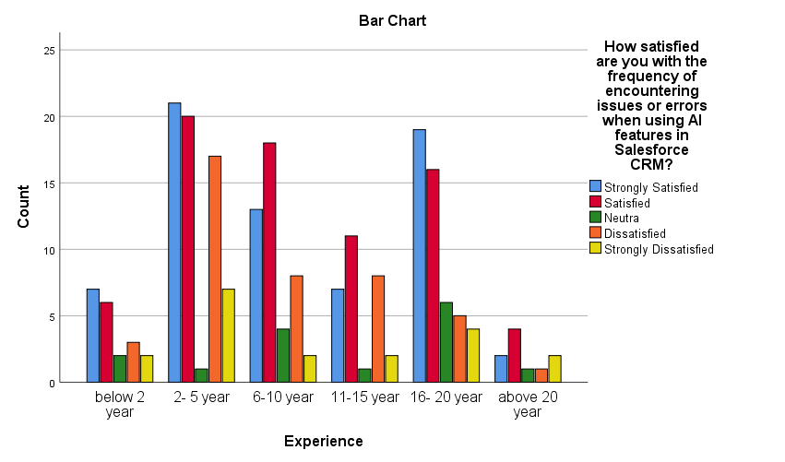

Figure 4.24: Experience * How satisfied are you with the frequency of encountering issues or errors when using AI features in Salesforce CRM? Crosstabulation

|  |  |  |  |  |  |  |
| --- | --- | --- | --- | --- | --- | --- |
|  | | How satisfied are you with the relevance of the recommendations or insights provided by AI-driven personalization in Salesforce CRM? | | | | |
| Strongly Satisfied | Satisfied | Neutra | Dissatisfied | Strongly Dissatisfied |
| Experience | below 2 year | 8 | 9 | 0 | 3 | 0 |
| 2- 5 year | 25 | 26 | 4 | 8 | 3 |
| 6-10 year | 15 | 14 | 4 | 6 | 6 |
| 11-15 year | 5 | 11 | 6 | 6 | 1 |
| 16- 20 year | 20 | 18 | 2 | 6 | 4 |
| above 20 year | 7 | 1 | 0 | 1 | 1 |
| Total | | 80 | 79 | 16 | 30 | 15 |

Table 4.25: Experience * How satisfied are you with the relevance of the recommendations or insights provided by AI-driven personalization in Salesforce CRM? Crosstabulation

AI-driven personalization in Salesforce CRM, when cross-referenced with experience, shows diverse responses. For those with less than 2 years of experience, the response is predominantly positive, with 17 individuals either strongly satisfied or satisfied, and only 3 dissatisfied. In the 2-5 year experience group, there's a notable lean towards satisfaction (25 strongly satisfied, 26 satisfied), although a few report dissatisfaction (11). The 6-10 year cohort displays a more balanced view, with 29 expressing satisfaction (15 strongly satisfied, 14 satisfied) and 12 indicating some level of dissatisfaction. Participants with 11-15 years of experience show mixed feelings, with a slight tilt towards satisfaction (16 satisfied/strongly satisfied), contrasted by 7 expressing dissatisfaction. The 16-20 year group tends towards satisfaction (20 strongly satisfied, 18 satisfied), but also reports dissatisfaction (10). Interestingly, those with over 20 years of experience have a varied response, with 7 strongly satisfied, but also 2 dissatisfied.

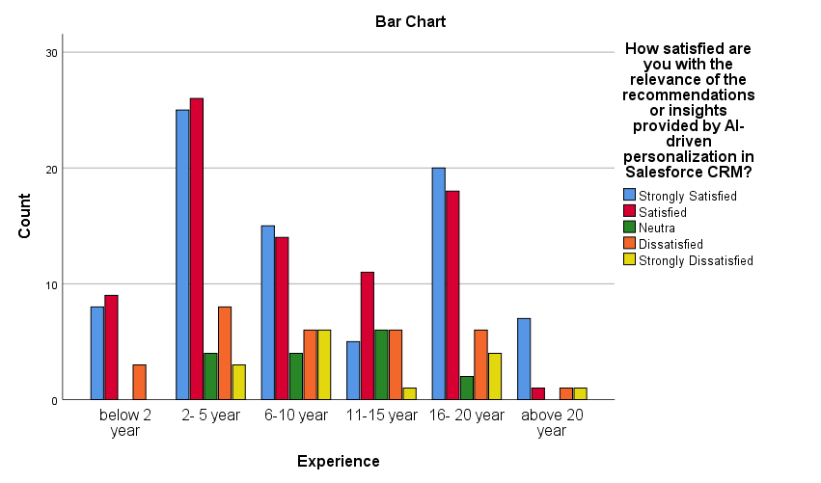

Figure 4.25: Experience * How satisfied are you with the relevance of the recommendations or insights provided by AI-driven personalization in Salesforce CRM? Crosstabulation

|  |  |  |  |  |  |  |
| --- | --- | --- | --- | --- | --- | --- |
|  | | How satisfied are you that AI-driven personalization enhances your engagement with the CRM system? | | | | |
|  | | Strongly Satisfied | Satisfied | Neutra | Dissatisfied | Strongly Dissatisfied |
| Experience | below 2 year | 7 | 5 | 3 | 4 | 1 |
|  | 2- 5 year | 25 | 19 | 6 | 7 | 9 |
|  | 6-10 year | 15 | 12 | 5 | 6 | 7 |
|  | 11-15 year | 5 | 13 | 3 | 4 | 4 |
|  | 16- 20 year | 21 | 12 | 4 | 9 | 4 |
|  | above 20 year | 5 | 4 | 0 | 1 | 0 |
| Total | | 78 | 65 | 21 | 31 | 25 |

**Table 4.26: Experience * How satisfied are you that AI-driven personalization enhances your engagement with the CRM system? Crosstabulation**

AI-driven personalization enhancing engagement with Salesforce CRM, the satisfaction levels vary with experience. Those with below 2 years of experience show a range of responses, with 7 strongly satisfied but also 5 dissatisfied or strongly dissatisfied. The 2-5 year group expresses a higher level of satisfaction (25 strongly satisfied, 19 satisfied) but also a notable degree of dissatisfaction (16). Participants with 6-10 years of experience present a mixed response, with 15 strongly satisfied but also 13 expressing dissatisfaction. The 11-15 year cohort leans slightly towards satisfaction (5 strongly satisfied, 13 satisfied), though dissatisfaction is also present (8). Those with 16-20 years of experience demonstrate a preference for AI-driven personalization (21 strongly satisfied, 12 satisfied), yet there's a significant count of dissatisfaction (13). Finally, individuals with over 20 years of experience predominantly express satisfaction (5 strongly satisfied, 4 satisfied) with minimal dissatisfaction.

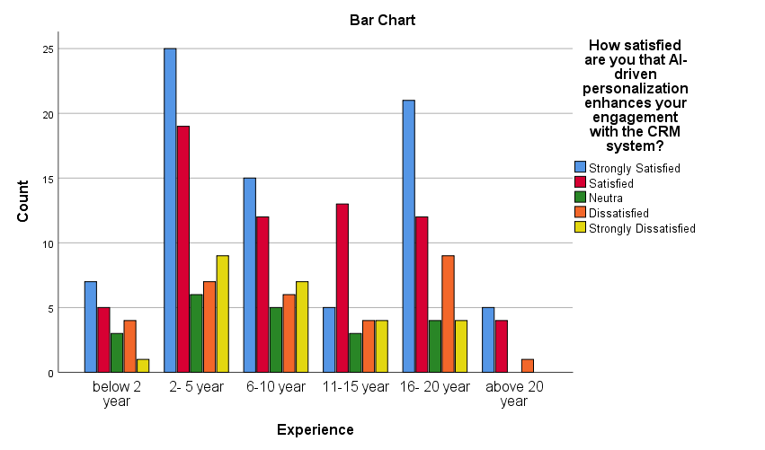

Figure 4.26: Experience * How satisfied are you that AI-driven personalization enhances your engagement with the CRM system? Crosstabulation

|  |  |  |  |  |  |  |
| --- | --- | --- | --- | --- | --- | --- |
|  | | How would you rate the intuitiveness of the user interface of AI-integrated features in Salesforce CRM? | | | | |
|  | | Highly Intuitive | Moderately Intuitive | Neutral | Somewhat Confusing | Very Confusing |
| Income Tax Slab? (Rupees) | Below 2.5 lacs | 9 | 10 | 0 | 6 | 0 |
|  | above 2.5 lacs -below 5 lacs | 19 | 10 | 3 | 6 | 2 |
|  | above 5 lacs - below 10 lacs | 10 | 6 | 2 | 3 | 0 |
|  | Above 10 lacs | 48 | 48 | 9 | 18 | 11 |
| Total | | 86 | 74 | 14 | 33 | 13 |

Table 4.27: Income Tax Slab? (Rupees) * How would you rate the intuitiveness of the user interface of AI-integrated features in Salesforce CRM? Crosstabulation

AI-integrated features' user interface in Salesforce CRM, categorized by income tax slabs, shows diverse perceptions. Individuals in the 'Below 2.5 lacs' income bracket mostly find the interface intuitive (19 highly or moderately intuitive) but some find it somewhat confusing (6). In the 'above 2.5 lacs - below 5 lacs' range, a majority also view the interface as intuitive (29 highly or moderately), with a few encountering confusion (8 somewhat or very confusing). Those earning 'above 5 lacs - below 10 lacs' generally perceive the interface as intuitive (16 highly or moderately), with fewer finding it neutral or confusing (5). However, in the 'Above 10 lacs' income bracket, while a significant number find the interface intuitive (96 highly or moderately), there's also a notable proportion who find it confusing (29 somewhat or very confusing).

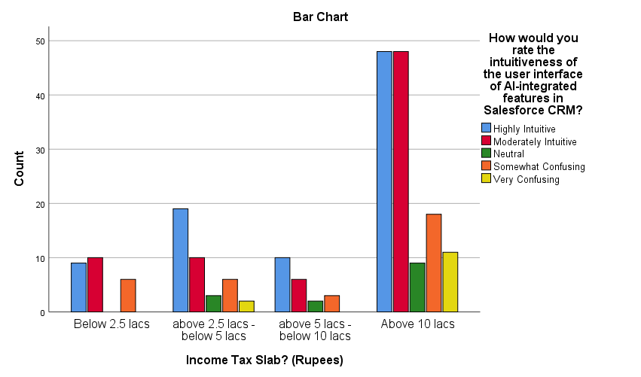

Figure 4.27: Income Tax Slab? (Rupees) * How would you rate the intuitiveness of the user interface of AI-integrated features in Salesforce CRM? Crosstabulation

|  |  |  |  |  |  |  |
| --- | --- | --- | --- | --- | --- | --- |
|  | | How satisfied are you with the responsiveness of the AI components within Salesforce CRM? | | | | |
| Strongly Satisfied | Satisfied | Neutra | Dissatisfied | Strongly Dissatisfied |
| Income Tax Slab? (Rupees) | Below 2.5 lacs | 9 | 8 | 2 | 6 | 0 |
| above 2.5 lacs -below 5 lacs | 17 | 6 | 11 | 5 | 1 |
| above 5 lacs - below 10 lacs | 6 | 5 | 4 | 3 | 3 |
| Above 10 lacs | 32 | 41 | 26 | 21 | 14 |
| Total | | 64 | 60 | 43 | 35 | 18 |

Table 4.28: Income Tax Slab? (Rupees) * How satisfied are you with the responsiveness of the AI components within Salesforce CRM? Crosstabulation

AI components in Salesforce CRM, segmented by income tax slabs, presents varied viewpoints. Users in the 'Below 2.5 lacs' bracket mostly express satisfaction (17 either strongly satisfied or satisfied), though some are neutral or dissatisfied (8). In the 'above 2.5 lacs - below 5 lacs' range, satisfaction is less pronounced (23 satisfied or strongly satisfied), with a noticeable number feeling neutral (11) and some dissatisfaction (6). For the 'above 5 lacs - below 10 lacs' group, the response is mixed, with 11 users satisfied or strongly satisfied, but also a balanced view of neutrality and dissatisfaction (10). The 'Above 10 lacs' income group, while having the highest satisfaction (73 satisfied or strongly satisfied), also reports the most dissatisfaction (35 dissatisfied or strongly dissatisfied) and neutrality (26).

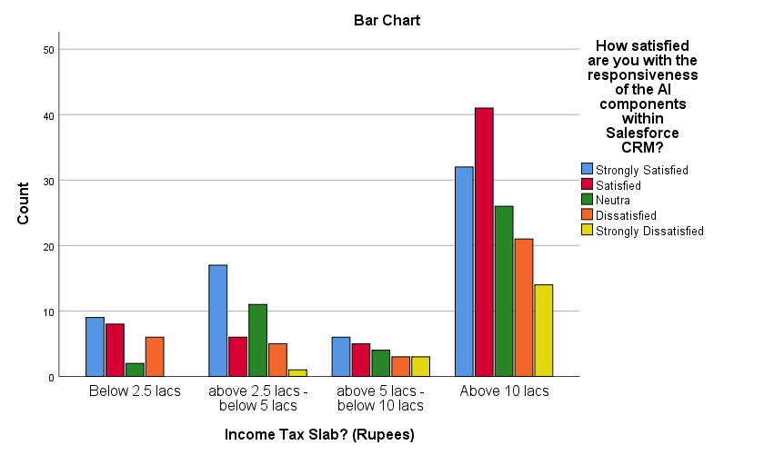

Figure 4.28: Income Tax Slab? (Rupees) * How satisfied are you with the responsiveness of the AI components within Salesforce CRM? Crosstabulation

|  |  |  |  |  |  |  |
| --- | --- | --- | --- | --- | --- | --- |
|  | | Regarding the main challenges with AI components in Salesforce CRM, how satisfied are you with the resolution or management of these challenges? | | | | |
| Strongly Satisfied | Satisfied | Neutra | Dissatisfied | Strongly Dissatisfied |
| Income Tax Slab? (Rupees) | Below 2.5 lacs | 9 | 7 | 0 | 7 | 2 |
| above 2.5 lacs -below 5 lacs | 8 | 13 | 1 | 11 | 7 |
| above 5 lacs - below 10 lacs | 9 | 8 | 1 | 2 | 1 |
| Above 10 lacs | 43 | 46 | 9 | 24 | 12 |
| Total | | 69 | 74 | 11 | 44 | 22 |

Table 4.29: Income Tax Slab? (Rupees) * Regarding the main challenges with AI components in Salesforce CRM, how satisfied are you with the resolution or management of these challenges? Crosstabulation

AI component challenges in Salesforce CRM, segmented by income tax slabs, the responses vary. Individuals in the 'Below 2.5 lacs' bracket show an even split between satisfaction (16) and dissatisfaction (9). For those earning 'above 2.5 lacs - below 5 lacs', there is a slight lean towards satisfaction (21), but dissatisfaction is also significant (18). The group with 'above 5 lacs - below 10 lacs' income generally perceives the resolution positively (17 satisfied), with a lower incidence of dissatisfaction (3). However, respondents in the 'Above 10 lacs' category, while predominantly satisfied (89), also report a notable level of dissatisfaction (36).

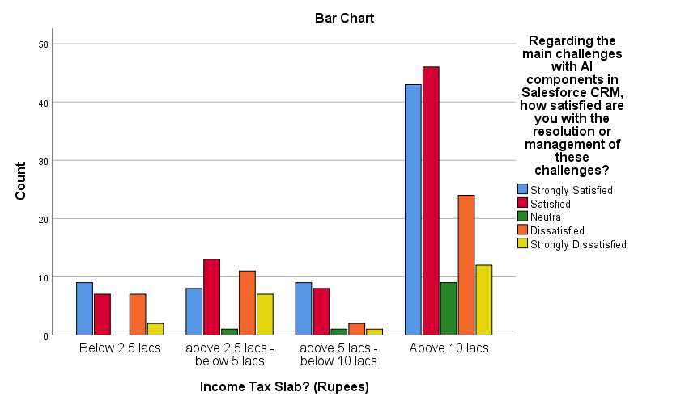

Figure 4.29: Income Tax Slab? (Rupees) * Regarding the main challenges with AI components in Salesforce CRM, how satisfied are you with the resolution or management of these challenges? Crosstabulation

|  |  |  |  |  |  |  |
| --- | --- | --- | --- | --- | --- | --- |
|  | | How satisfied are you with the frequency of encountering issues or errors when using AI features in Salesforce CRM? | | | | |
| Strongly Satisfied | Satisfied | Neutra | Dissatisfied | Strongly Dissatisfied |
| Job Role | Salesforce developer | 9 | 7 | 2 | 4 | 2 |
| Salesforce consultant | 21 | 22 | 3 | 16 | 10 |
| Salesforce technical lead | 21 | 28 | 5 | 19 | 3 |
| Salesforce architect | 18 | 18 | 5 | 3 | 4 |
| Total | | 69 | 75 | 15 | 42 | 19 |

Table 4.30: Job Role * How satisfied are you with the frequency of encountering issues or errors when using AI features in Salesforce CRM? Crosstabulation

The satisfaction levels regarding the frequency of encountering issues or errors with AI features in Salesforce CRM, when viewed by job role, show varied experiences. Salesforce Developers largely indicate satisfaction, with 16 out of 24 being satisfied or strongly satisfied, but there are instances of dissatisfaction (6). Salesforce Consultants present a more mixed response, with 43 indicating satisfaction, while a notable portion (26) express dissatisfaction or neutrality. Salesforce Technical Leads have a majority expressing satisfaction (49 satisfied or strongly satisfied), but there's also a significant number experiencing dissatisfaction (22). Salesforce Architects, on the other hand, show a higher satisfaction level (36 satisfied or strongly satisfied), with fewer instances of dissatisfaction (7).

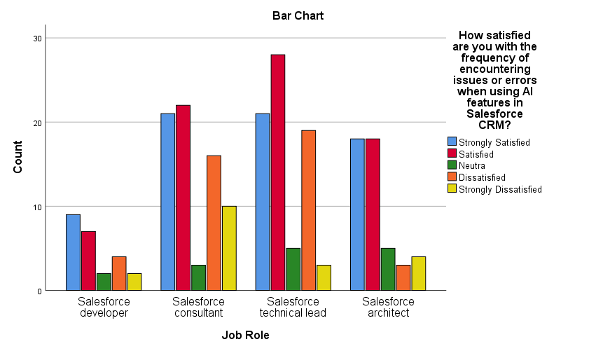

Figure 4.30: Job Role * How satisfied are you with the frequency of encountering issues or errors when using AI features in Salesforce CRM? Crosstabulation

|  |  |  |  |  |  |  |
| --- | --- | --- | --- | --- | --- | --- |
|  | | How satisfied are you with the relevance of the recommendations or insights provided by AI-driven personalization in Salesforce CRM? | | | | |
| Strongly Satisfied | Satisfied | Neutra | Dissatisfied | Strongly Dissatisfied |
| Job Role | Salesforce developer | 9 | 11 | 0 | 3 | 1 |
| Salesforce consultant | 24 | 26 | 8 | 11 | 3 |
| Salesforce technical lead | 26 | 25 | 7 | 10 | 8 |
| Salesforce architect | 21 | 17 | 1 | 6 | 3 |
| Total | | 80 | 79 | 16 | 30 | 15 |

Table 4.31: Job Role * How satisfied are you with the relevance of the recommendations or insights provided by AI-driven personalization in Salesforce CRM? Crosstabulation

In assessing satisfaction with the relevance of recommendations or insights from AI-driven personalization in Salesforce CRM, differing levels of contentment are observed across job roles. Salesforce Developers predominantly express satisfaction, with 20 individuals either strongly satisfied or satisfied, though a few face dissatisfaction (4). Salesforce Consultants have a significant number indicating satisfaction (50 satisfied or strongly satisfied), but there's also a notable presence of neutrality (8) and dissatisfaction (14). Salesforce Technical Leads display a high level of satisfaction (51 satisfied or strongly satisfied), yet dissatisfaction is also evident (18). Salesforce Architects, while majorly satisfied (38 satisfied or strongly satisfied), encounter some dissatisfaction (9).

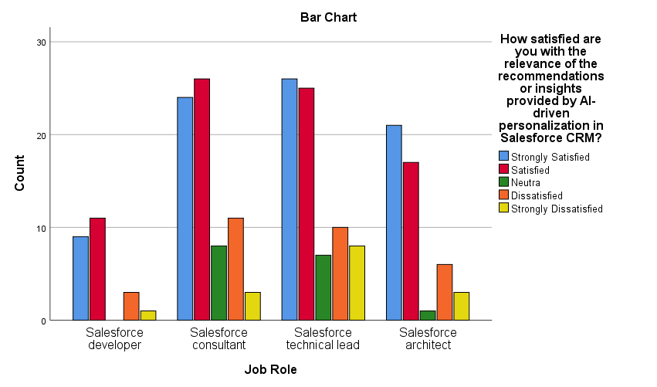

Figure 4.31: Job Role * How satisfied are you with the relevance of the recommendations or insights provided by AI-driven personalization in Salesforce CRM? Crosstabulation

|  |  |  |  |  |  |  |
| --- | --- | --- | --- | --- | --- | --- |
|  | | How satisfied are you that AI-driven personalization enhances your engagement with the CRM system? | | | | |
| Strongly Satisfied | Satisfied | Neutra | Dissatisfied | Strongly Dissatisfied |
| Job Role | Salesforce developer | 8 | 7 | 3 | 4 | 2 |
| Salesforce consultant | 25 | 22 | 7 | 10 | 8 |
| Salesforce technical lead | 24 | 23 | 7 | 10 | 12 |
| Salesforce architect | 21 | 13 | 4 | 7 | 3 |
| Total | | 78 | 65 | 21 | 31 | 25 |

Table 4.32: Job Role * How satisfied are you that AI-driven personalization enhances your engagement with the CRM system? Crosstabulation

The satisfaction levels regarding AI-driven personalization's impact on engagement with Salesforce CRM, as perceived by different job roles, show a range of responses. Salesforce Developers exhibit a balanced satisfaction, with 15 expressing satisfaction or strong satisfaction, but also a few instances of neutrality and dissatisfaction (9). Salesforce Consultants display a similar trend, with 47 indicating satisfaction, yet there's a considerable number experiencing neutrality (7) or dissatisfaction (18). Salesforce Technical Leads show a strong sense of satisfaction (47 satisfied or strongly satisfied), though there's a notable presence of dissatisfaction as well (22). Salesforce Architects lean towards satisfaction (34 satisfied or strongly satisfied), but there are also instances of dissatisfaction (10).

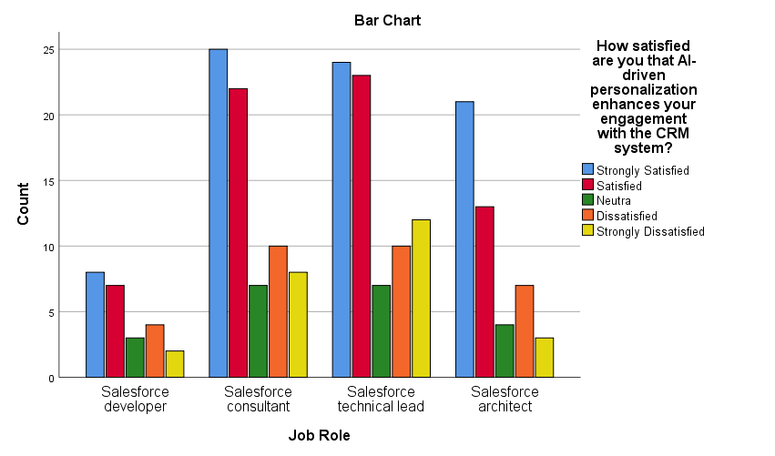

Figure 4.32: Job Role * How satisfied are you that AI-driven personalization enhances your engagement with the CRM system? Crosstabulation

## CHAPTER 5

## RESULTS

|  |  |  |  |  |  |  |  |
| --- | --- | --- | --- | --- | --- | --- | --- |
|  | | Gender | Age | Qualification | Experience | Income Tax Slab? (Rupees) | Job Role |
| Which AI feature in Salesforce CRM do you think requires the most immediate refinement, in terms of your satisfaction? | Pearson Correlation | -0.055 | -0.045 | -0.029 | -0.068 | -0.068 | -0.074 |
| Sig. (2-tailed) | 0.414 | 0.510 | 0.674 | 0.312 | 0.319 | 0.271 |
| N | 220 | 220 | 220 | 220 | 220 | 220 |
| Which aspect of AI features would you prioritize for improvement, in terms of your satisfaction? | Pearson Correlation | 0.095 | 0.033 | -0.004 | 0.039 | -0.018 | 0.007 |
| Sig. (2-tailed) | 0.160 | 0.629 | 0.948 | 0.566 | 0.792 | 0.919 |
| N | 220 | 220 | 220 | 220 | 220 | 220 |
| Which is more important to you: having advanced AI capabilities, ensuring user-friendliness or data security in Salesforce CRM? | Pearson Correlation | -0.016 | -0.028 | 0.013 | -0.019 | -0.088 | -0.097 |
| Sig. (2-tailed) | 0.818 | 0.678 | 0.850 | 0.784 | 0.194 | 0.153 |
| N | 220 | 220 | 220 | 220 | 220 | 220 |
| If Salesforce CRM were to focus on one area for improvement in its AI integration, which area would you prefer? | Pearson Correlation | 0.040 | -0.046 | 0.031 | 0.012 | -0.027 | 0.018 |
| Sig. (2-tailed) | 0.552 | 0.500 | 0.644 | 0.862 | 0.692 | 0.790 |
| N | 220 | 220 | 220 | 220 | 220 | 220 |
| How would you rate the intuitiveness of the user interface of AI-integrated features in Salesforce CRM? | Pearson Correlation | -0.023 | 0.045 | -0.006 | 0.109 | 0.051 | 0.073 |
| Sig. (2-tailed) | 0.735 | 0.505 | 0.931 | 0.106 | 0.452 | 0.281 |
| N | 220 | 220 | 220 | 220 | 220 | 220 |
| In comparison with non-AI features, how satisfied are you with the enhancement brought by AI-integrated tools in your overall experience with Salesforce CRM? | Pearson Correlation | 0.099 | -0.013 | -0.006 | 0.002 | 0.023 | 0.028 |
| Sig. (2-tailed) | 0.144 | 0.847 | 0.928 | 0.972 | 0.730 | 0.684 |
| N | 220 | 220 | 220 | 220 | 220 | 220 |
| How satisfied are you with the responsiveness of the AI components within Salesforce CRM? | Pearson Correlation | 0.005 | 0.099 | -.174** | 0.099 | 0.131 | 0.079 |
| Sig. (2-tailed) | 0.940 | 0.143 | 0.010 | 0.141 | 0.053 | 0.246 |
| N | 220 | 220 | 220 | 220 | 220 | 220 |
| How satisfied are you with the way AI features in Salesforce CRM understand and cater to your requests or queries? | Pearson Correlation | 0.002 | 0.017 | 0.020 | 0.052 | 0.123 | 0.043 |
| Sig. (2-tailed) | 0.979 | 0.806 | 0.763 | 0.442 | 0.069 | 0.528 |
| N | 220 | 220 | 220 | 220 | 220 | 220 |
| How satisfied are you with the consistency of timely and relevant responses from AI components within Salesforce CRM to your inputs? | Pearson Correlation | 0.032 | 0.029 | -0.096 | 0.071 | 0.064 | 0.004 |
| Sig. (2-tailed) | 0.635 | 0.664 | 0.156 | 0.296 | 0.345 | 0.956 |
| N | 220 | 220 | 220 | 220 | 220 | 220 |
| How satisfied are you with the frequency of encountering issues or errors when using AI features in Salesforce CRM? | Pearson Correlation | 0.124 | -0.019 | -0.041 | -0.036 | -0.029 | -0.090 |
| Sig. (2-tailed) | 0.067 | 0.775 | 0.545 | 0.599 | 0.666 | 0.185 |
| N | 220 | 220 | 220 | 220 | 220 | 220 |
| How would you rate your overall user experience with AI-integrated features in Salesforce CRM? | Pearson Correlation | -0.054 | -0.015 | -0.033 | 0.006 | -0.050 | -0.011 |
| Sig. (2-tailed) | 0.424 | 0.824 | 0.627 | 0.928 | 0.458 | 0.870 |
| N | 220 | 220 | 220 | 220 | 220 | 220 |
| Based on your experience, how satisfied are you with the likelihood of recommending the AI features of Salesforce CRM to a colleague or peer? | Pearson Correlation | 0.027 | 0.016 | 0.050 | 0.031 | 0.008 | -0.030 |
| Sig. (2-tailed) | 0.695 | 0.809 | 0.464 | 0.642 | 0.902 | 0.662 |
| N | 220 | 220 | 220 | 220 | 220 | 220 |
| How satisfied are you with the frequency of your utilization of AI-enabled personalization features within Salesforce CRM? | Pearson Correlation | -0.007 | 0.008 | 0.063 | 0.004 | 0.010 | -0.001 |
| Sig. (2-tailed) | 0.921 | 0.903 | 0.356 | 0.948 | 0.888 | 0.994 |
| N | 220 | 220 | 220 | 220 | 220 | 220 |
| How satisfied are you with the relevance of the recommendations or insights provided by AI-driven personalization in Salesforce CRM? | Pearson Correlation | 0.009 | -0.038 | -0.054 | 0.031 | 0.076 | -0.002 |
| Sig. (2-tailed) | 0.899 | 0.574 | 0.423 | 0.650 | 0.264 | 0.973 |
| N | 220 | 220 | 220 | 220 | 220 | 220 |
| How satisfied are you that AI-driven personalization enhances your engagement with the CRM system? | Pearson Correlation | -0.084 | -0.064 | -0.079 | -0.047 | -0.009 | -0.042 |
| Sig. (2-tailed) | 0.214 | 0.343 | 0.245 | 0.492 | 0.894 | 0.539 |
| N | 220 | 220 | 220 | 220 | 220 | 220 |
| How satisfied are you with the impact of AI-driven personalization on improving your customer interactions? | Pearson Correlation | 0.041 | 0.010 | 0.002 | -0.017 | 0.057 | 0.056 |
| Sig. (2-tailed) | 0.546 | 0.884 | 0.972 | 0.798 | 0.399 | 0.405 |
| N | 220 | 220 | 220 | 220 | 220 | 220 |
| How satisfied are you with the reduction in manual data inputs or adjustments due to AI-enabled personalization? | Pearson Correlation | .137* | -0.066 | -0.024 | 0.007 | 0.028 | -0.039 |
| Sig. (2-tailed) | 0.042 | 0.332 | 0.718 | 0.913 | 0.680 | 0.566 |
| N | 220 | 220 | 220 | 220 | 220 | 220 |
| How satisfied are you with how AI-enabled personalization features respect user and customer privacy? | Pearson Correlation | 0.103 | 0.027 | 0.010 | 0.057 | 0.039 | 0.103 |
| Sig. (2-tailed) | 0.129 | 0.687 | 0.882 | 0.396 | 0.563 | 0.129 |
| N | 220 | 220 | 220 | 220 | 220 | 220 |
| How satisfied are you with the current level of advanced personalization features in Salesforce CRM, and the prospect of more in future updates? | Pearson Correlation | 0.086 | 0.026 | 0.005 | 0.042 | 0.080 | 0.060 |
| Sig. (2-tailed) | 0.202 | 0.705 | 0.942 | 0.538 | 0.235 | 0.375 |
| N | 220 | 220 | 220 | 220 | 220 | 220 |
| How satisfied are you with how often AI-personalized recommendations align with your expectations or requirements? | Pearson Correlation | -0.088 | 0.036 | -0.074 | -0.012 | 0.070 | 0.066 |
| Sig. (2-tailed) | 0.191 | 0.591 | 0.276 | 0.859 | 0.301 | 0.327 |
| N | 220 | 220 | 220 | 220 | 220 | 220 |
| How satisfied are you with the frequency of feeling overwhelmed or confused by the AI features in Salesforce CRM? | Pearson Correlation | -0.110 | -0.121 | -.159* | -0.062 | -0.080 | -0.025 |
| Sig. (2-tailed) | 0.104 | 0.074 | 0.018 | 0.362 | 0.237 | 0.708 |
| N | 220 | 220 | 220 | 220 | 220 | 220 |
| Regarding the main challenges with AI components in Salesforce CRM, how satisfied are you with the resolution or management of these challenges? | Pearson Correlation | -0.027 | -0.065 | -0.005 | -0.081 | -0.082 | -0.055 |
| Sig. (2-tailed) | 0.689 | 0.340 | 0.939 | 0.229 | 0.224 | 0.414 |
| N | 220 | 220 | 220 | 220 | 220 | 220 |
| How satisfied are you with the frequency of resorting to manual methods due to challenges faced with AI components? | Pearson Correlation | -0.022 | 0.009 | 0.099 | 0.020 | 0.015 | 0.019 |
| Sig. (2-tailed) | 0.746 | 0.891 | 0.143 | 0.763 | 0.825 | 0.785 |
| N | 220 | 220 | 220 | 220 | 220 | 220 |
| How would you rate your satisfaction with the training or guidance provided for AI features in Salesforce CRM? | Pearson Correlation | -0.069 | 0.024 | 0.046 | 0.083 | 0.024 | 0.039 |
| Sig. (2-tailed) | 0.308 | 0.722 | 0.493 | 0.220 | 0.722 | 0.569 |
| N | 220 | 220 | 220 | 220 | 220 | 220 |
| How satisfied are you that AI components sometimes make decisions or recommendations that align with business objectives? | Pearson Correlation | -0.010 | 0.046 | -0.060 | 0.090 | 0.020 | 0.059 |
| Sig. (2-tailed) | 0.884 | 0.498 | 0.380 | 0.183 | 0.772 | 0.387 |
| N | 220 | 220 | 220 | 220 | 220 | 220 |
| How satisfied are you with the ease of overriding or adjusting AI-driven actions or recommendations in Salesforce CRM? | Pearson Correlation | -0.003 | -0.058 | 0.078 | 0.005 | -0.018 | 0.011 |
| Sig. (2-tailed) | 0.964 | 0.393 | 0.247 | 0.940 | 0.789 | 0.874 |
| N | 220 | 220 | 220 | 220 | 220 | 220 |
| Do you believe there's a need for improved transparency regarding how AI components make decisions within Salesforce CRM? | Pearson Correlation | 0.019 | 0.103 | -0.058 | 0.132 | 0.080 | 0.080 |
| Sig. (2-tailed) | 0.782 | 0.126 | 0.394 | 0.050 | 0.239 | 0.238 |
| N | 220 | 220 | 220 | 220 | 220 | 220 |
| How satisfied are you with the frequency at which you provide feedback on challenges faced with AI components in Salesforce CRM? | Pearson Correlation | -0.083 | 0.037 | 0.065 | 0.001 | 0.012 | 0.044 |
| Sig. (2-tailed) | 0.222 | 0.587 | 0.341 | 0.991 | 0.858 | 0.512 |
| N | 220 | 220 | 220 | 220 | 220 | 220 |
| How satisfied are you with the improvements or updates made in response to feedback regarding AI challenges in Salesforce CRM? | Pearson Correlation | -0.111 | 0.028 | 0.017 | 0.048 | 0.036 | 0.024 |
| Sig. (2-tailed) | 0.102 | 0.677 | 0.797 | 0.481 | 0.590 | 0.721 |
| N | 220 | 220 | 220 | 220 | 220 | 220 |
| How satisfied are you with the frequency at which you encounter features that don't align with your workflow or business objectives in Salesforce CRM? | Pearson Correlation | -0.029 | -0.014 | -0.029 | -0.003 | 0.015 | -0.051 |
| Sig. (2-tailed) | 0.671 | 0.839 | 0.674 | 0.965 | 0.821 | 0.456 |
| N | 220 | 220 | 220 | 220 | 220 | 220 |
| How satisfied are you with the customization options for AI features in Salesforce CRM? | Pearson Correlation | -0.069 | -0.034 | 0.046 | 0.015 | -0.020 | -0.040 |
| Sig. (2-tailed) | 0.308 | 0.611 | 0.500 | 0.828 | 0.770 | 0.556 |
| N | 220 | 220 | 220 | 220 | 220 | 220 |
| How satisfied are you with how well the AI in Salesforce CRM adapts to changes in your business environment or requirements? | Pearson Correlation | 0.097 | .135* | 0.005 | 0.129 | 0.105 | 0.063 |
| Sig. (2-tailed) | 0.151 | 0.046 | 0.942 | 0.057 | 0.121 | 0.352 |
| N | 220 | 220 | 220 | 220 | 220 | 220 |
| How satisfied are you with the frequency at which you have to manually correct or override AI-generated outputs in Salesforce CRM? | Pearson Correlation | 0.056 | 0.059 | -0.013 | 0.064 | 0.066 | 0.017 |
| Sig. (2-tailed) | 0.407 | 0.387 | 0.845 | 0.346 | 0.331 | 0.807 |
| N | 220 | 220 | 220 | 220 | 220 | 220 |
| In terms of user-friendliness, how satisfied are you with the AI components of Salesforce CRM compared to other systems you've used? | Pearson Correlation | 0.029 | 0.113 | 0.083 | .180** | .138* | .174** |
| Sig. (2-tailed) | 0.664 | 0.094 | 0.222 | 0.007 | 0.041 | 0.010 |
| N | 220 | 220 | 220 | 220 | 220 | 220 |
| Would a more detailed user guide or tutorial improve your satisfaction with AI features in Salesforce CRM? | Pearson Correlation | -0.015 | 0.023 | 0.034 | 0.057 | 0.029 | 0.053 |
| Sig. (2-tailed) | 0.822 | 0.734 | 0.612 | 0.397 | 0.667 | 0.435 |
| N | 220 | 220 | 220 | 220 | 220 | 220 |
| How satisfied are you with how well the AI features in Salesforce CRM are integrated with other CRM functionalities? | Pearson Correlation | 0.032 | 0.120 | 0.051 | .143* | .147* | .167* |
| Sig. (2-tailed) | 0.633 | 0.075 | 0.455 | 0.034 | 0.030 | 0.013 |
| N | 220 | 220 | 220 | 220 | 220 | 220 |
| How would you rate your satisfaction with the overall reliability of AI features in Salesforce CRM? | Pearson Correlation | 0.127 | 0.014 | 0.128 | 0.036 | 0.010 | 0.007 |
| Sig. (2-tailed) | 0.059 | 0.835 | 0.059 | 0.594 | 0.883 | 0.921 |
| N | 220 | 220 | 220 | 220 | 220 | 220 |
| How satisfied are you with how well Salesforce CRM strikes a balance between advanced AI functionalities and user-friendliness? | Pearson Correlation | -0.069 | 0.085 | 0.035 | 0.055 | 0.077 | -0.004 |
| Sig. (2-tailed) | 0.307 | 0.211 | 0.605 | 0.418 | 0.254 | 0.958 |
| N | 220 | 220 | 220 | 220 | 220 | 220 |
| How satisfied are you with the frequency at which you feel advanced functionalities of AI in Salesforce CRM come at the cost of user-friendliness? | Pearson Correlation | 0.061 | -0.029 | 0.072 | 0.012 | 0.017 | 0.019 |
| Sig. (2-tailed) | 0.366 | 0.665 | 0.287 | 0.860 | 0.803 | 0.780 |
| N | 220 | 220 | 220 | 220 | 220 | 220 |
| Would you prefer a more streamlined version of Salesforce CRM with fewer AI functionalities but more focus on user-friendliness, and data security? | Pearson Correlation | -0.037 | -0.034 | -0.042 | -0.027 | -0.014 | -0.012 |
| Sig. (2-tailed) | 0.586 | 0.618 | 0.540 | 0.686 | 0.836 | 0.860 |
| N | 220 | 220 | 220 | 220 | 220 | 220 |
| How satisfied are you with how well Salesforce CRM accepts and implements user feedback on AI features? | Pearson Correlation | -0.052 | 0.011 | -0.066 | 0.054 | 0.077 | 0.028 |
| Sig. (2-tailed) | 0.440 | 0.874 | 0.332 | 0.422 | 0.256 | 0.680 |
| N | 220 | 220 | 220 | 220 | 220 | 220 |
| How satisfied are you with your frequency of utilizing Salesforce CRM's feedback mechanism to share thoughts on AI functionalities? | Pearson Correlation | 0.077 | -0.020 | 0.070 | -0.011 | -0.049 | -0.015 |
| Sig. (2-tailed) | 0.258 | 0.764 | 0.300 | 0.872 | 0.465 | 0.828 |
| N | 220 | 220 | 220 | 220 | 220 | 220 |
| How satisfied are you that updates or modifications made based on user feedback genuinely enhance the AI features' performance and usability in Salesforce CRM? | Pearson Correlation | -0.046 | 0.004 | -0.041 | -0.039 | -0.015 | -0.019 |
| Sig. (2-tailed) | 0.496 | 0.951 | 0.549 | 0.570 | 0.827 | 0.784 |
| N | 220 | 220 | 220 | 220 | 220 | 220 |
| How satisfied are you with how proactive Salesforce CRM is in seeking user feedback regarding AI components and functionalities? | Pearson Correlation | 0.069 | -0.084 | 0.055 | -0.056 | -0.081 | -0.074 |
| Sig. (2-tailed) | 0.308 | 0.212 | 0.414 | 0.407 | 0.230 | 0.277 |
| N | 220 | 220 | 220 | 220 | 220 | 220 |
| How satisfied are you with the frequency at which new AI functionalities in Salesforce CRM are introduced without compromising the system's user-friendliness? | Pearson Correlation | -0.067 | -0.052 | 0.054 | -0.038 | -0.025 | -0.078 |
| Sig. (2-tailed) | 0.321 | 0.440 | 0.424 | 0.571 | 0.711 | 0.249 |
| N | 220 | 220 | 220 | 220 | 220 | 220 |

Table 5.1: Bivariate correlation

* 1. **Bivariate correlation**

**Satisfaction with the Responsiveness of AI Components within Salesforce CRM:**

* **Qualification:** Pearson Correlation: -0.174**, Sig. (2-tailed): 0.010.
* **Interpretation:** There's a weak to moderate negative correlation with qualification, which is statistically significant. This suggests that individuals with different qualifications may vary slightly in their satisfaction with the responsiveness of the AI components.

1. **Satisfaction with Reduction in Manual Data Inputs due to AI-Enabled Personalization:**

* **Gender:** Pearson Correlation: 0.137*, Sig. (2-tailed): 0.042.
* **Interpretation:** A weak positive correlation with gender, which is statistically significant, indicates a slight difference in satisfaction based on gender regarding the reduction in manual data inputs.

1. **Satisfaction with Frequency of Feeling Overwhelmed by AI Features:**

* **Qualification:** Pearson Correlation: -0.159*, Sig. (2-tailed): 0.018.
* Interpretation: A weak negative correlation with qualification, significant statistically, suggests that satisfaction levels regarding feeling overwhelmed by AI features may vary slightly based on educational qualifications.

1. **Satisfaction with AI Adaptation to Changes in Business Environment:**

* **Age:** Pearson Correlation: 0.135*, Sig. (2-tailed): 0.046.
* Interpretation: A weak positive correlation with age, which is statistically significant, implies that satisfaction with how well the AI adapts to business changes might vary slightly with age.

1. **Satisfaction with User-Friendliness of AI Components Compared to Other Systems:**

* **Experience:** Pearson Correlation: 0.180**, Sig. (2-tailed): 0.007.
* **Qualification:** Pearson Correlation: 0.138*, Sig. (2-tailed): 0.041.
* **Job Role:** Pearson Correlation: 0.174**, Sig. (2-tailed): 0.010.
* These weak to moderate correlations suggest that satisfaction with user-friendliness varies based on experience, qualification, and job role, with those having more experience, higher qualifications, or certain job roles potentially being more satisfied.

1. **Satisfaction with Integration of AI Features with Other CRM Functionalities:**

* **Experience:** Pearson Correlation: 0.143*, Sig. (2-tailed): 0.034.
* **Qualification:** Pearson Correlation: 0.147*, Sig. (2-tailed): 0.030.
* **Job Role:** Pearson Correlation: 0.167*, Sig. (2-tailed): 0.013.
* Interpretation: Weak positive correlations in these categories indicate that individuals with different levels of experience, qualifications, and job roles may experience varying levels of satisfaction with how AI features are integrated into other CRM functionalities.
  1. **ANOVA**

|  |  |  |  |
| --- | --- | --- | --- |
| Model | Variables Entered | Variables Removed | Method |
| 1 | data security, customer interactions, Customer privacy, reliability of AI features, user-friendliness, interface AI | . | Enter |

Table 5.2: Variables Entered/Removed

The data interpretation for your study, "Assessing the Impacts and Impediments of AI Integration in Salesforce CRM: A Comprehensive User-Centric Study", based on the provided data, can be outlined as follows:

**Variables Entered/Removed**

* **Variables Entered in the Model:** Data security, customer interactions, customer privacy, reliability of AI features, user-friendliness, and AI interface.
* **Method Used:** Enter method, meaning all these variables were entered into the regression analysis simultaneously.

|  |  |  |  |  |
| --- | --- | --- | --- | --- |
| Model | R | R Square | Adjusted R Square | Std. Error of the Estimate |
| 1 | .296 | .088 | .062 | 1.168 |

Table 5.3: Model Summary

**Model Summary**

* **R (Correlation Coefficient) = 0.296:** This indicates a low to moderate positive correlation between the independent variables (data security, customer interactions, customer privacy, reliability of AI features, user-friendliness, and AI interface) and the dependent variable (possibly the effectiveness or efficiency of Salesforce CRM with AI integration).
* **R Square = 0.088:** This means that about 8.8% of the variance in the dependent variable is explained by the independent variables collectively. It's a relatively low percentage, suggesting that while these factors have some impact, there are likely other significant factors influencing the outcome that are not included in this model.
* **Adjusted R Square = 0.062:** This value, which adjusts for the number of predictors in the model, suggests that around 6.2% of the variance in the dependent variable is explained by the model. This further emphasizes the presence of other influential factors not captured by the current model.
* **Std. Error of the Estimate = 1.168:** This indicates the average distance that the observed values fall from the regression line. A lower number here would indicate a better fit.

|  |  |  |  |  |  |  |
| --- | --- | --- | --- | --- | --- | --- |
| Model | | Sum of Squares | df | Mean Square | F | Sig. |
| 1 | Regression | 27.932 | 6 | 4.655 | 3.411 | .003 |
| Residual | 290.663 | 213 | 1.365 |  |  |
| Total | 318.595 | 219 |  |  |  |

Table 5.4: ANOVA

**ANOVA (Analysis of Variance)**

**F-Statistic = 3.411, Significance (Sig.) = .003:** The F-value tests whether at least one predictor variable has a non-zero coefficient. A significance level of .003, which is less than 0.05, suggests that the model is statistically significant. This means we can reject the null hypothesis that all regression coefficients are zero, implying that the model, with the variables included, does make a significant contribution to explaining the variability in the dependent variable.

* 1. **Reliability**

|  |  |  |  |
| --- | --- | --- | --- |
| S.no. | parameters | N of Items | Cronbach's Alpha |
| 1 | AI Integration in Salesforce CRM | 45 | .707 |

Table 5.5: Reliability

**Cronbach's Alpha:** The Cronbach's Alpha value of .707 for your scale measuring AI Integration in Salesforce CRM indicates an acceptable level of internal consistency. This statistic is a measure of the extent to which all the items in a test measure the same concept or construct and is thus connected to the inter-relatedness of the items within the scale.

## Chapter 6

## Conclusion

* 1. **Conclusion**

In the study "Assessing the Impacts and Impediments of AI Integration in Salesforce CRM: A Comprehensive User-Centric Study," the intricate relationship between AI integration and user satisfaction within Salesforce CRM was scrutinized. The findings, derived from a thorough analysis involving bivariate correlations and regression models, revealed a nuanced picture: demographic factors such as gender, age, qualification, experience, and job role exhibited weak to moderate correlations with user satisfaction, suggesting a complex interplay between user characteristics and their experiences with AI features. More strikingly, pivotal variables like data security, customer interactions, customer privacy, reliability, user-friendliness, and AI interface were found to explain only a modest portion of the variance in Salesforce CRM's effectiveness or efficiency, highlighting the multifaceted nature of AI integration in professional settings. This study not only illuminates the subtleties in how users interact with and perceive AI in CRM systems but also underscores the need for broader investigations that encompass a wider range of influencing factors, including organizational context and individual adaptation strategies, to fully understand and enhance the AI-user experience in Salesforce CRM.

* 1. **Suggestions**
* **User-Friendly Design:** Given the importance of user-friendliness, Salesforce CRM should focus on streamlining AI features to enhance accessibility and ease of use.
* **Targeted Training:** Customized training and guidance for different user groups based on their professional backgrounds and qualifications could enhance user satisfaction and efficiency.
* **Focus on Personalization:** Enhancing AI-driven personalization to align more closely with user expectations and workflows can significantly improve user experience.
* **Improving Integration:** There is scope for improving how AI features integrate with other CRM functionalities, ensuring a seamless user experience.
  1. **Limitations**
* **Sample Diversity:** The study primarily focuses on users with specific demographic characteristics. A more diverse sample could provide a broader understanding of user satisfaction across different sectors.
* **Scope of Variables:** The variables included in the study, while comprehensive, do not account for all possible factors influencing user satisfaction, such as organizational culture or specific industry needs.
* **Subjective Measures:** The reliance on self-reported measures of satisfaction might introduce biases or inaccuracies in the data.
  1. **Future Scope**
* **Expanding Research Demographics:** Future studies could include a more diverse range of participants from various industries and backgrounds to generalize the findings more broadly.
* **Incorporating Qualitative Insights:** Qualitative research, such as interviews or focus groups, could provide deeper insights into user experiences and preferences.
* **Longitudinal Studies:** Conducting longitudinal studies to track how user satisfaction evolves with continued use of AI in Salesforce CRM could provide valuable insights into long-term impacts and user adaptation.
* **Technological Advances:** As AI technology advances, future research could explore the impacts of newer AI functionalities on user satisfaction and CRM efficiency.

## References: